**Name-Priyanshu Sinha**

**S.I.C. No.-22BEEC35**

**AWS PROJECT**

**Branch-Electrical and Electronics Enginnering**

**SILICON INSTITUTE OF TECHNOLOGY**

**1.CREATED OUR OWN VPC**

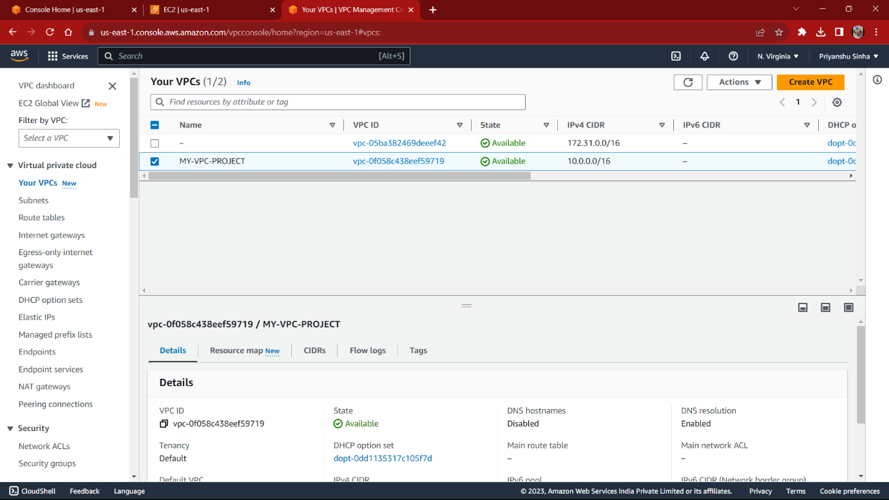

**2. CREATED TWO SUBNETS IN OUR OWN VPC (PRIVATE & PUBLIC)**

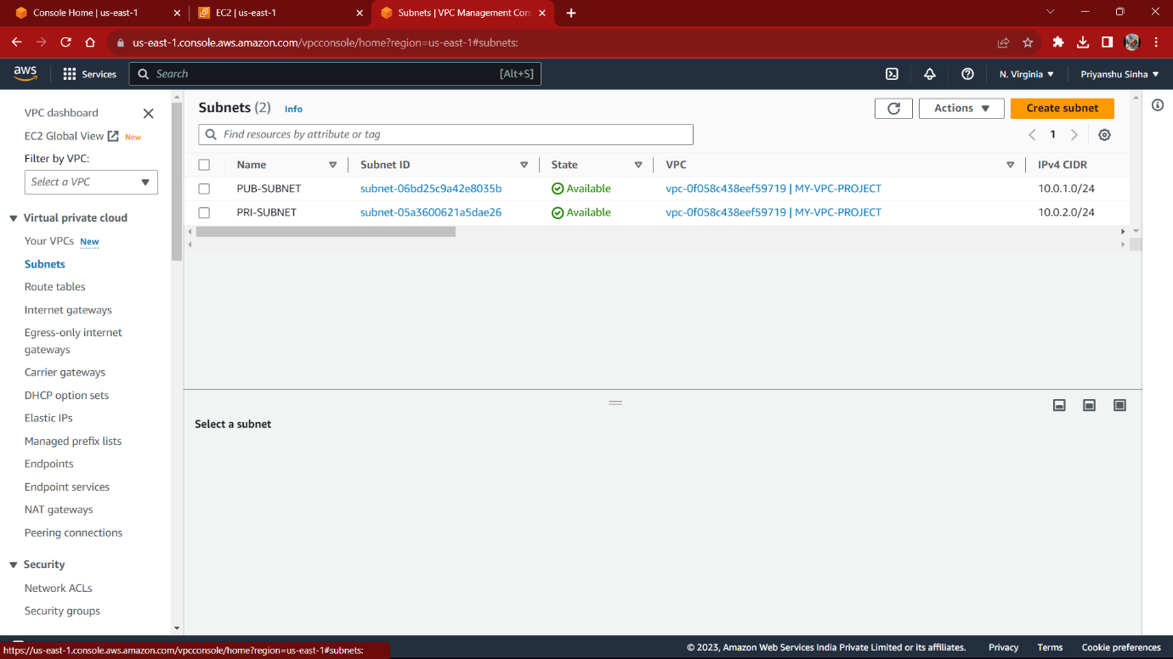

3. LAUNCHING TWO EC2 INSTANCES ON OUR PUBLIC SUBNET

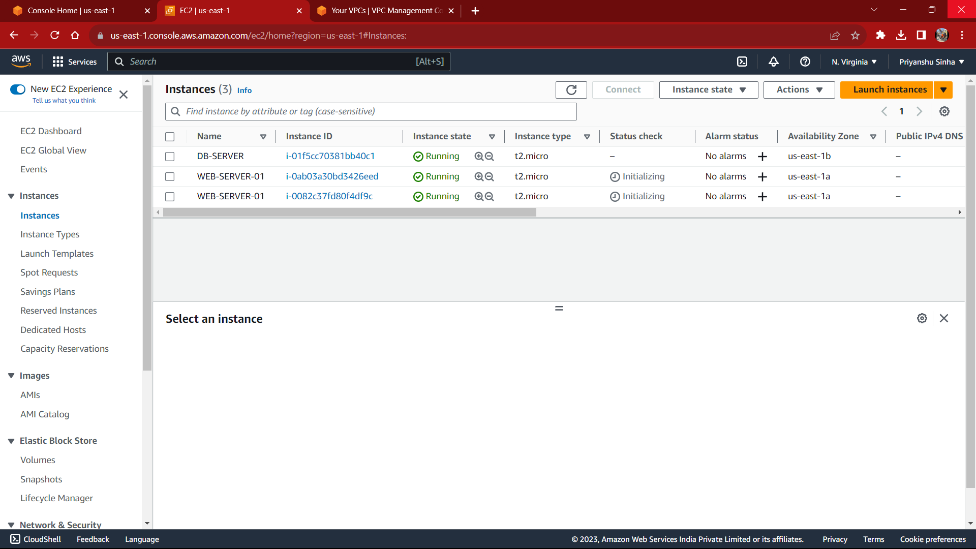

4.CREATING AN INTERNET GATEWAY TO CONNECT TO VPC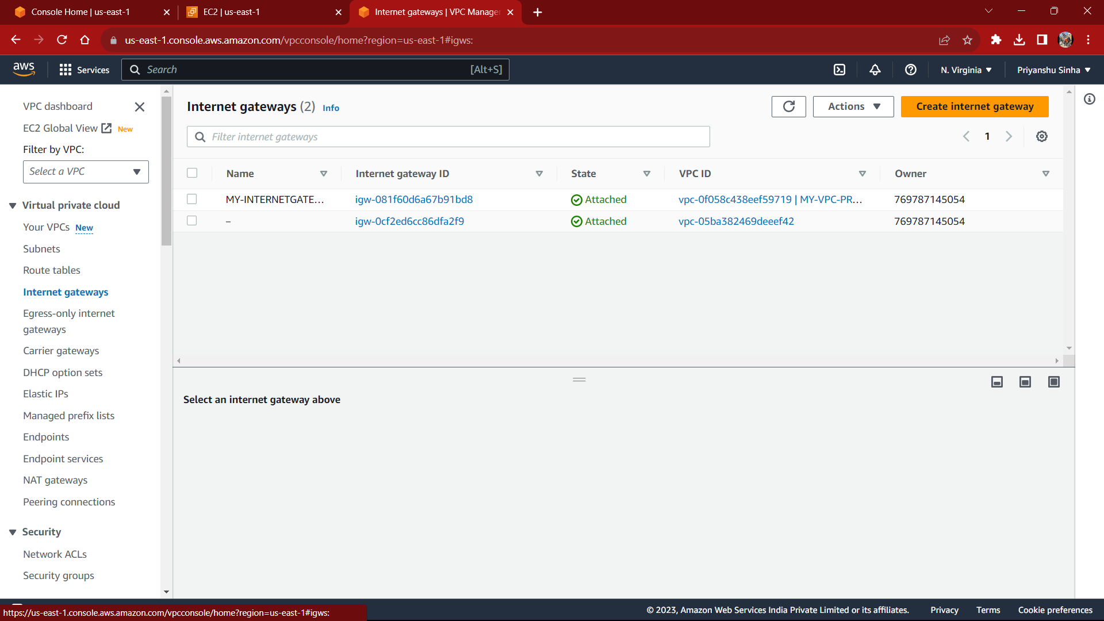

5.CREATE A ROUTE TABLE IN OUR VPC AND ATTACH INTERNET GATEWAY TO IT 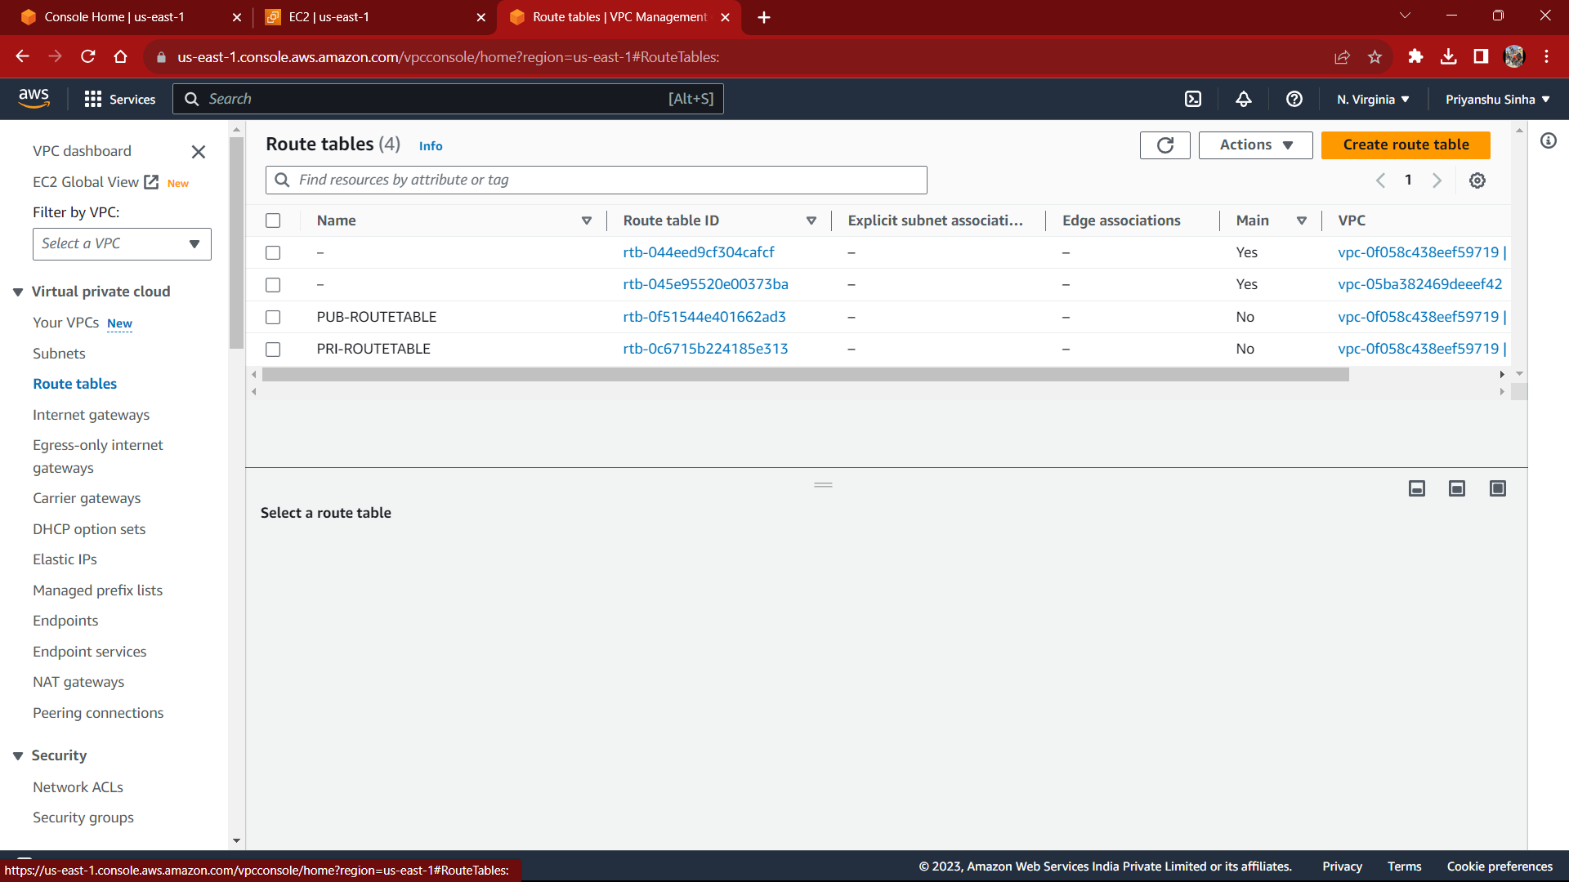

6. LAUNCHING TWO EC2 INSTANCES

WEB-SERVER-01 AND CONNECT WITH SERVER

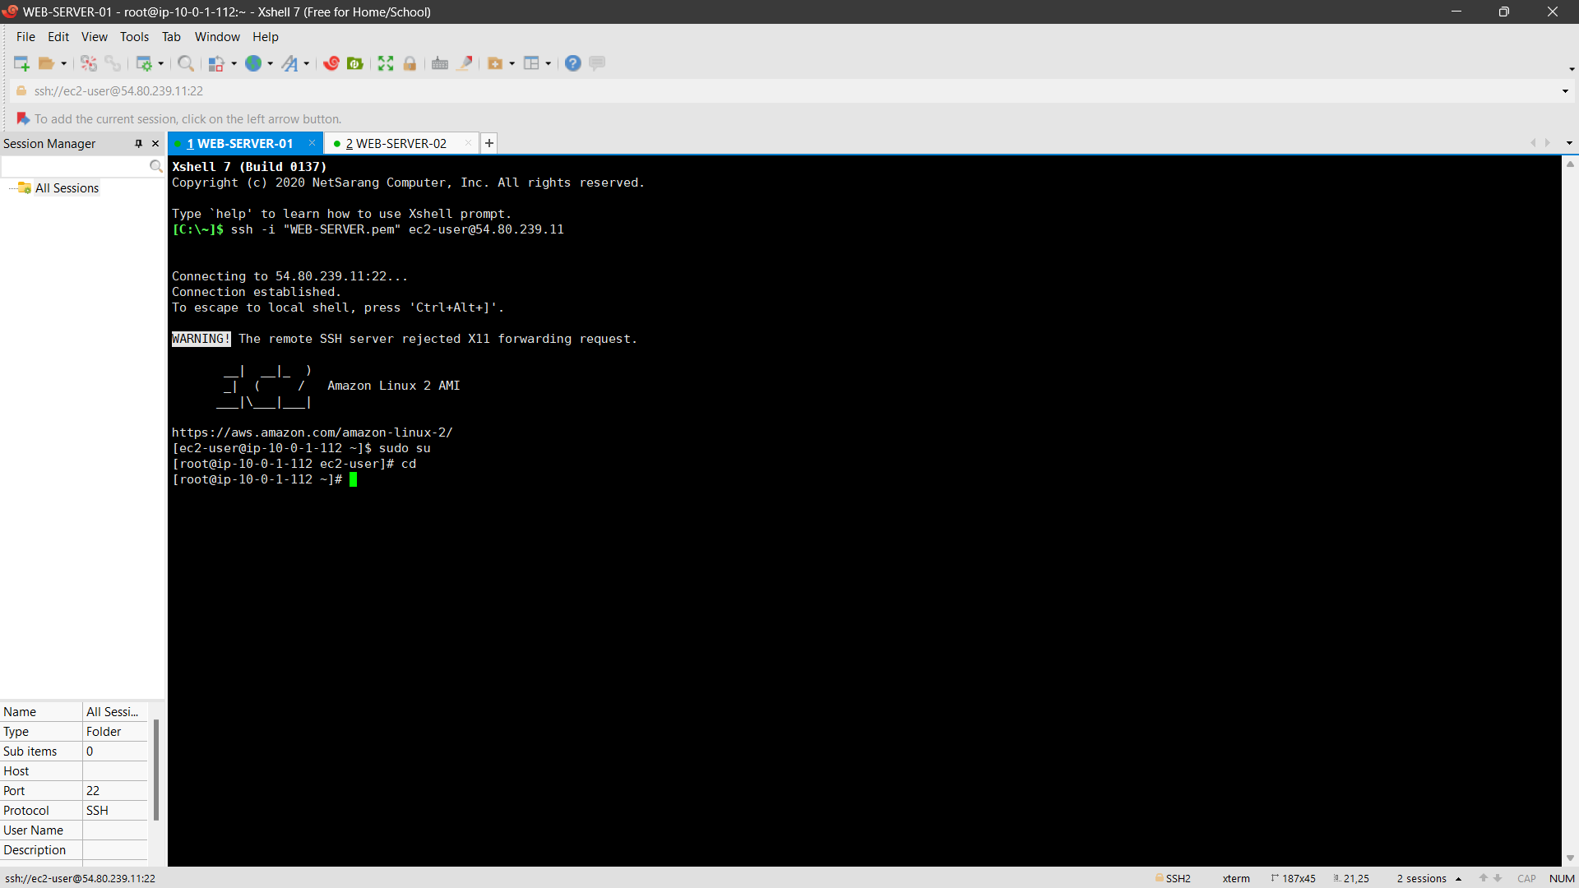

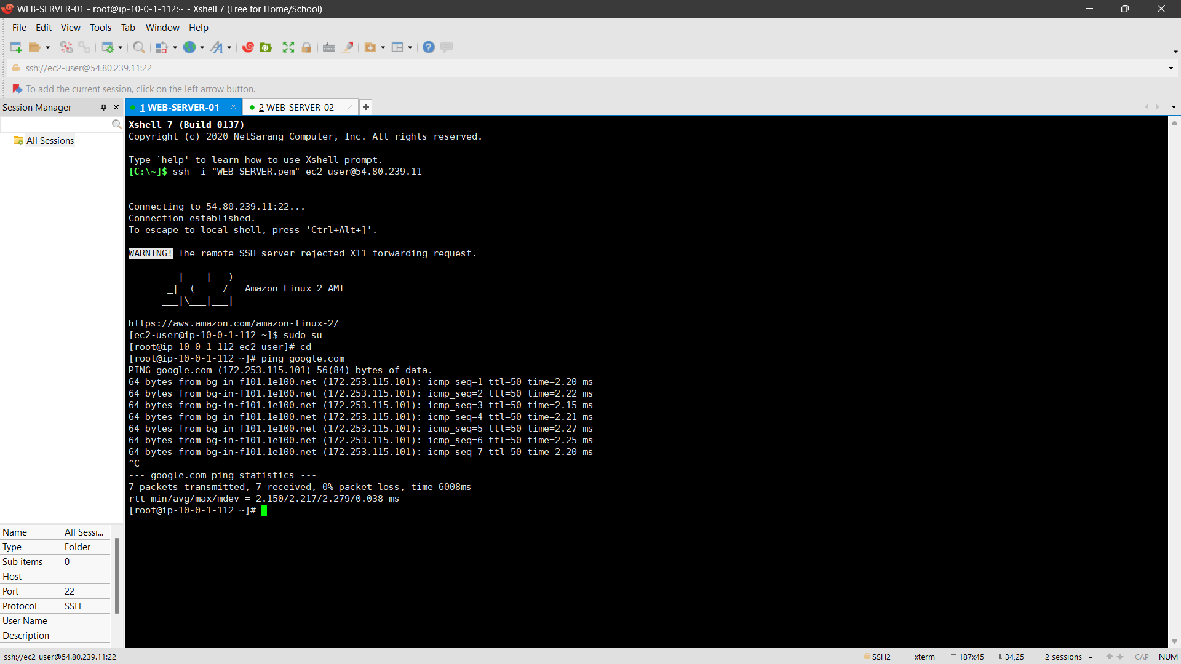

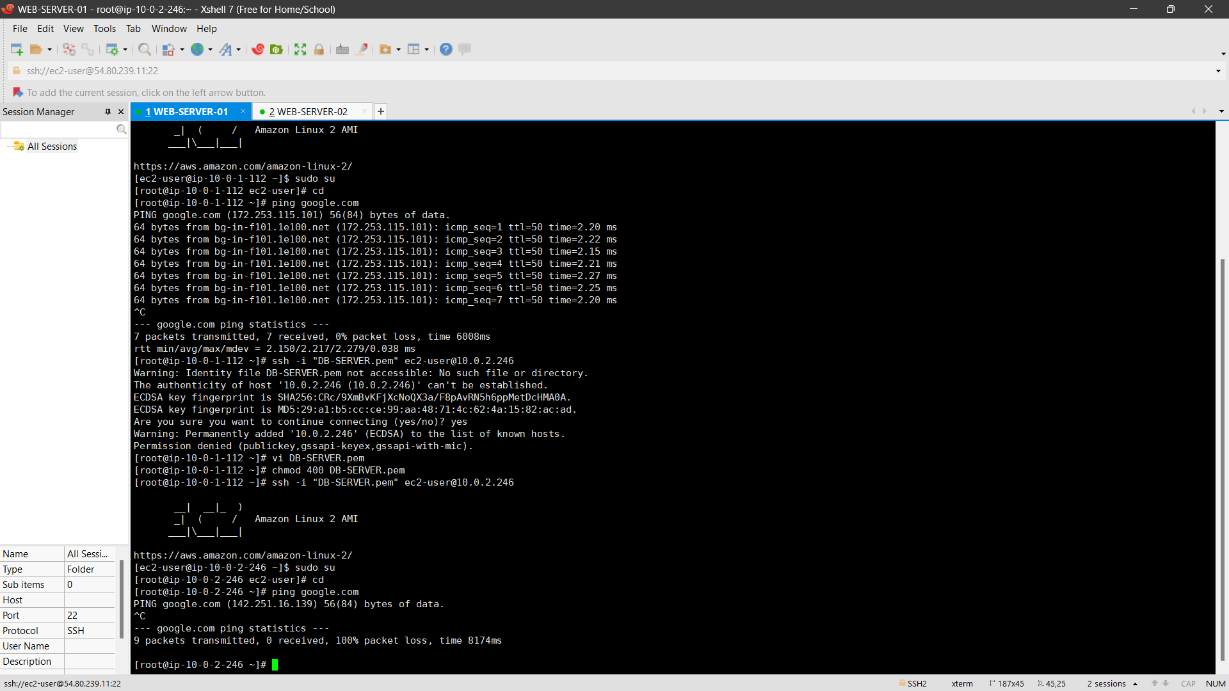

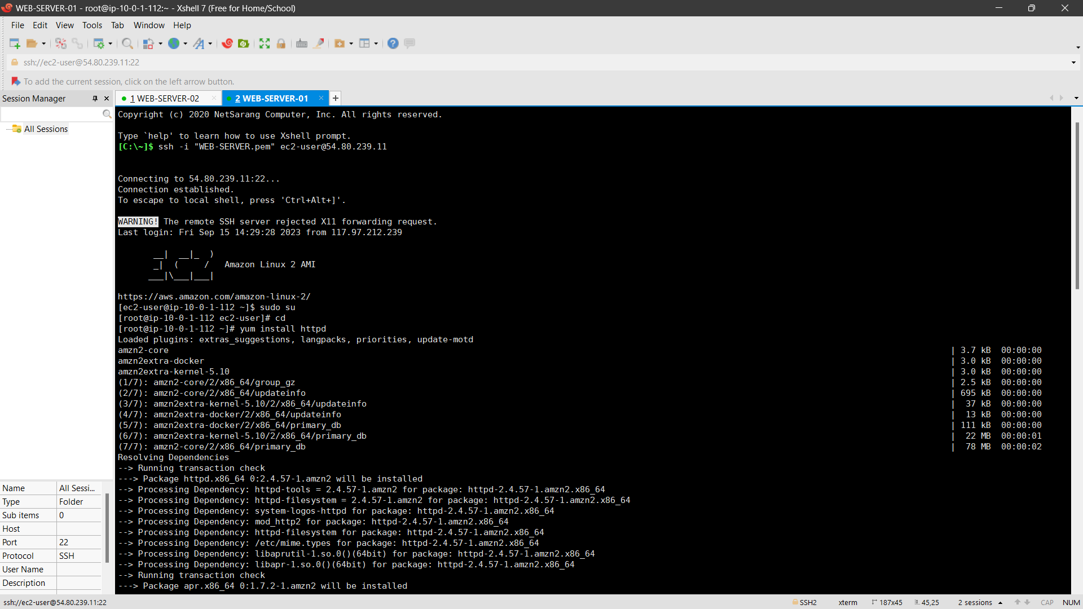

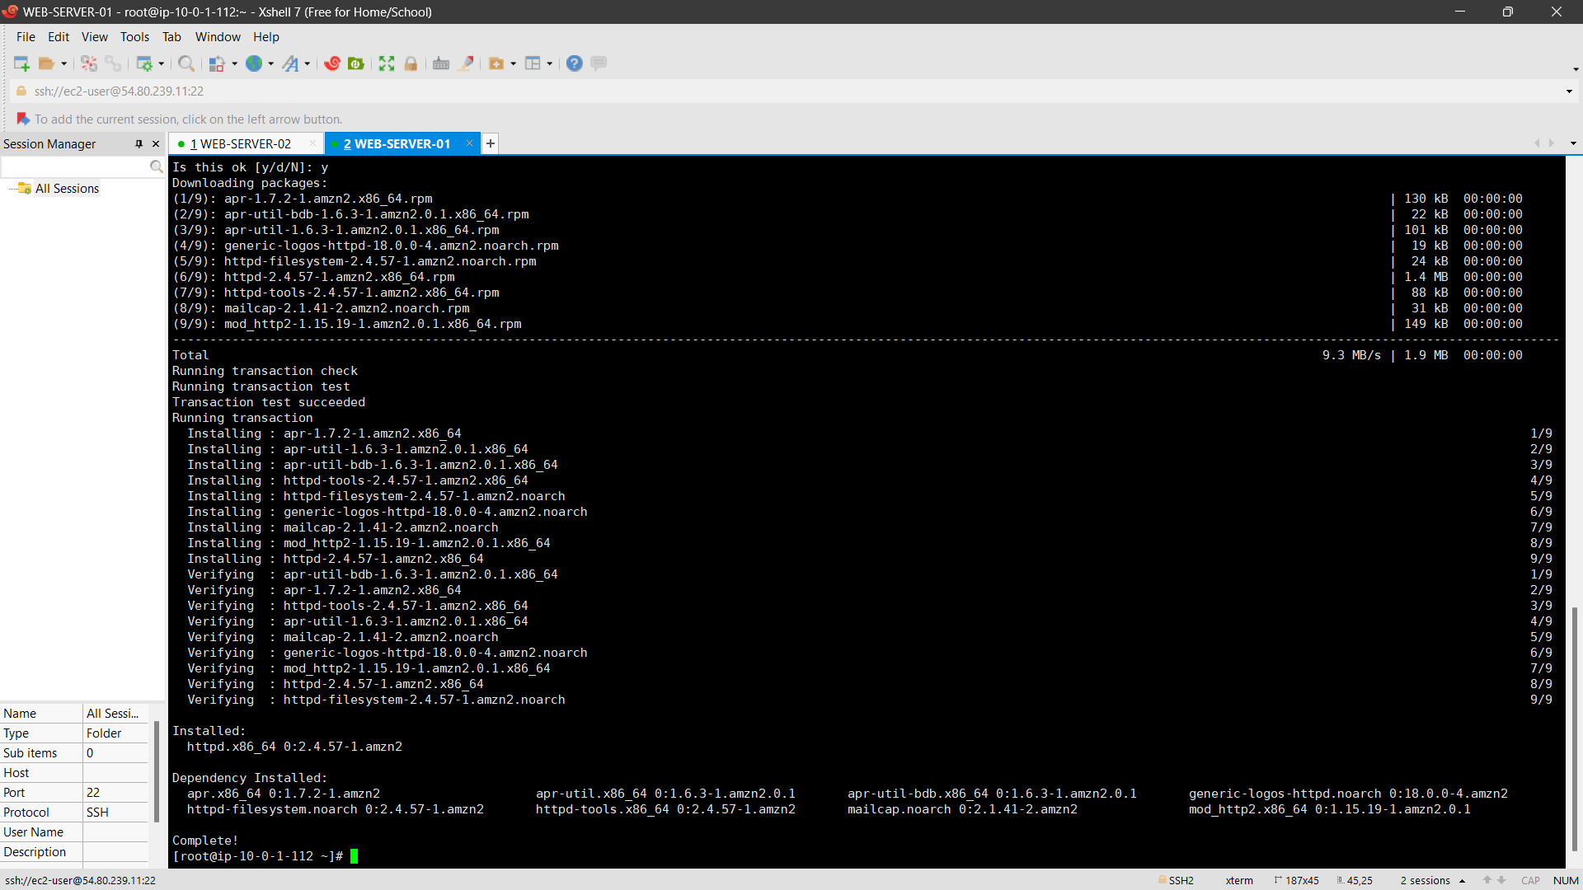

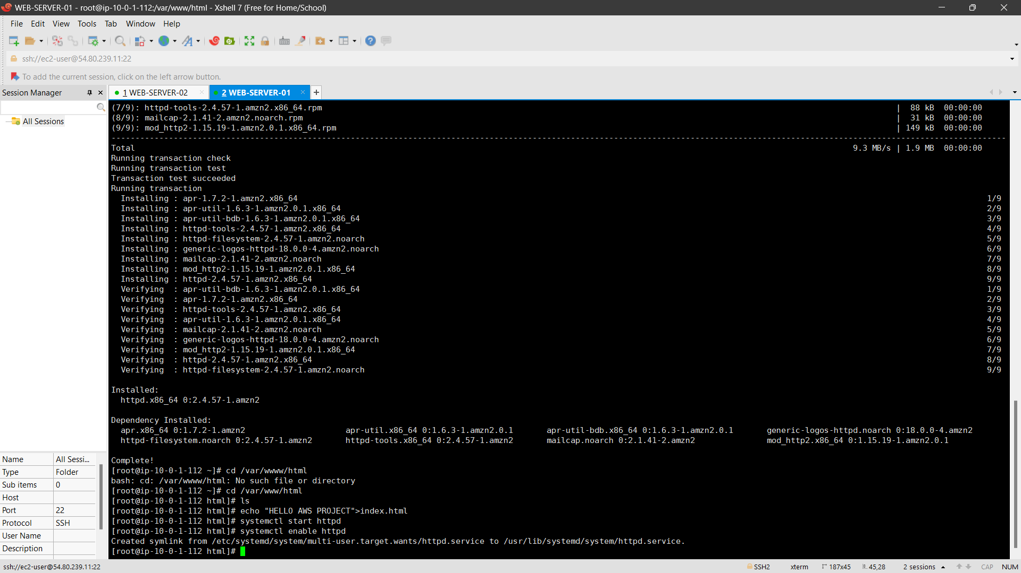

SERVER CONNECTD WITH IP ADDRESS**: *54.80.239.11***



WEB-SERVER-02 AND CONNECT WITH SERVER

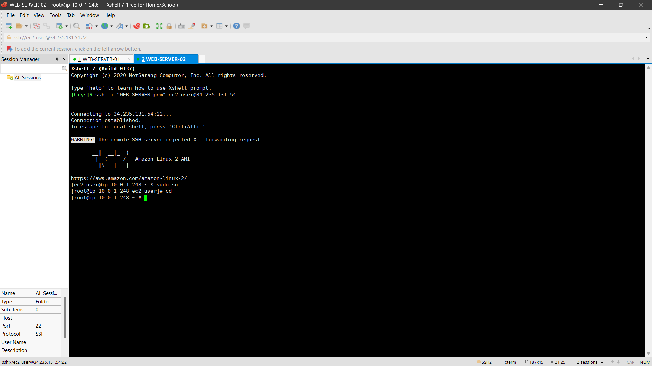

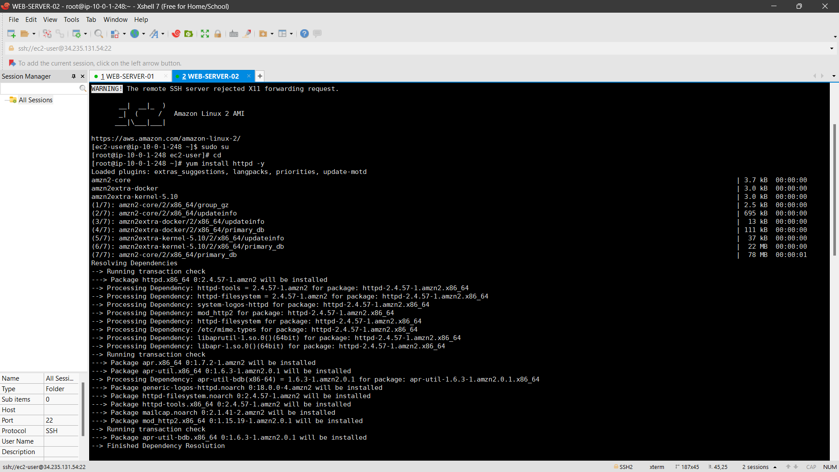

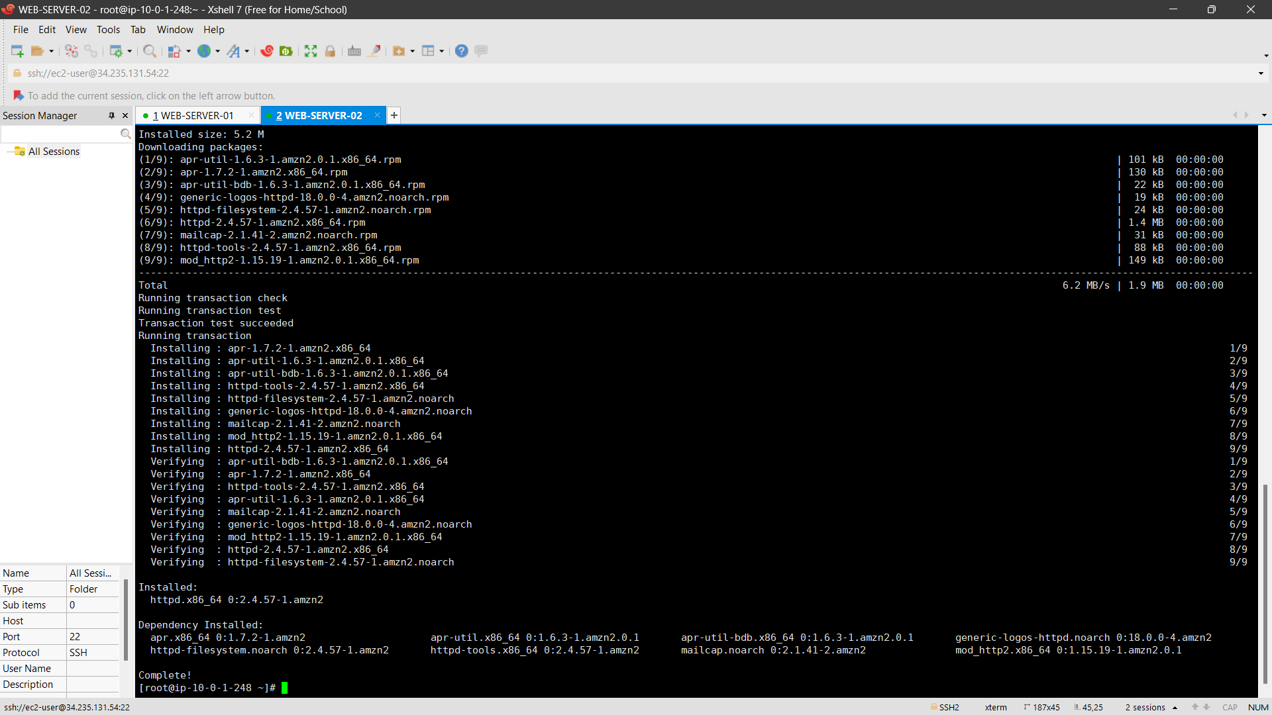

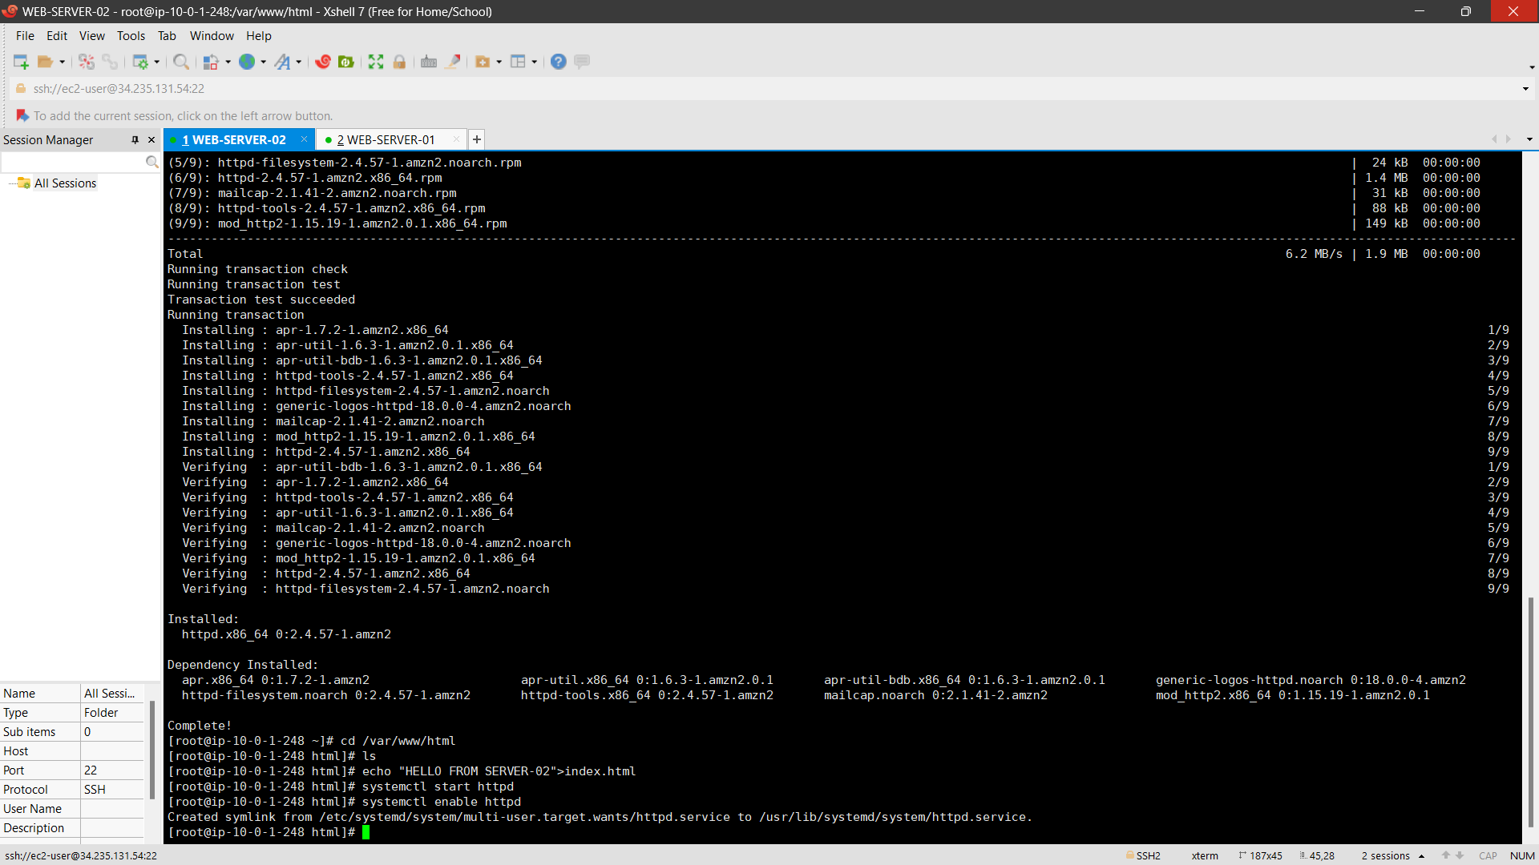

SERVER CONNECTD WITH IP ADDRESS**: *34.235.131.54***



7.UPDATE ROUTE TABLE

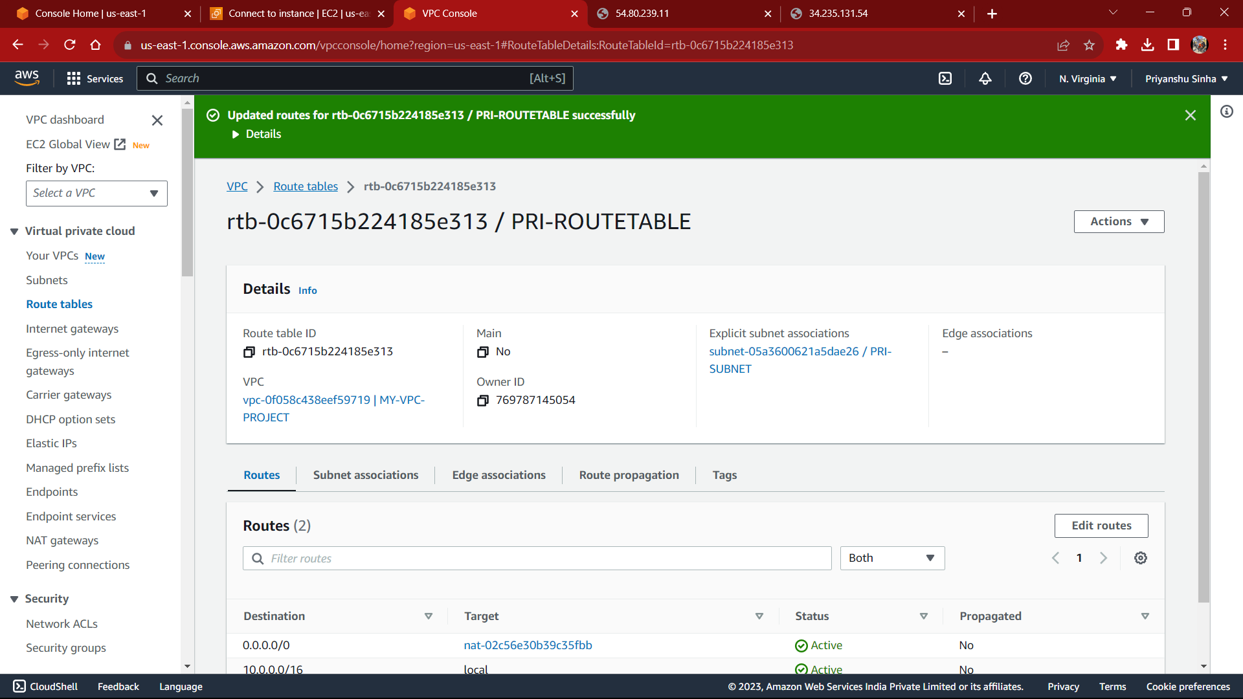

8.UPDATE NAT GATEWAY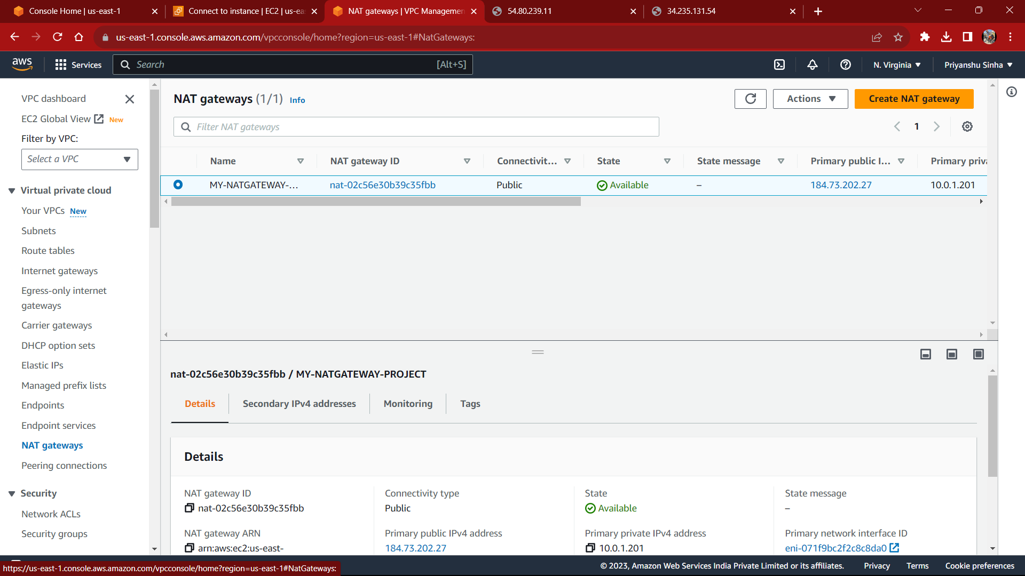

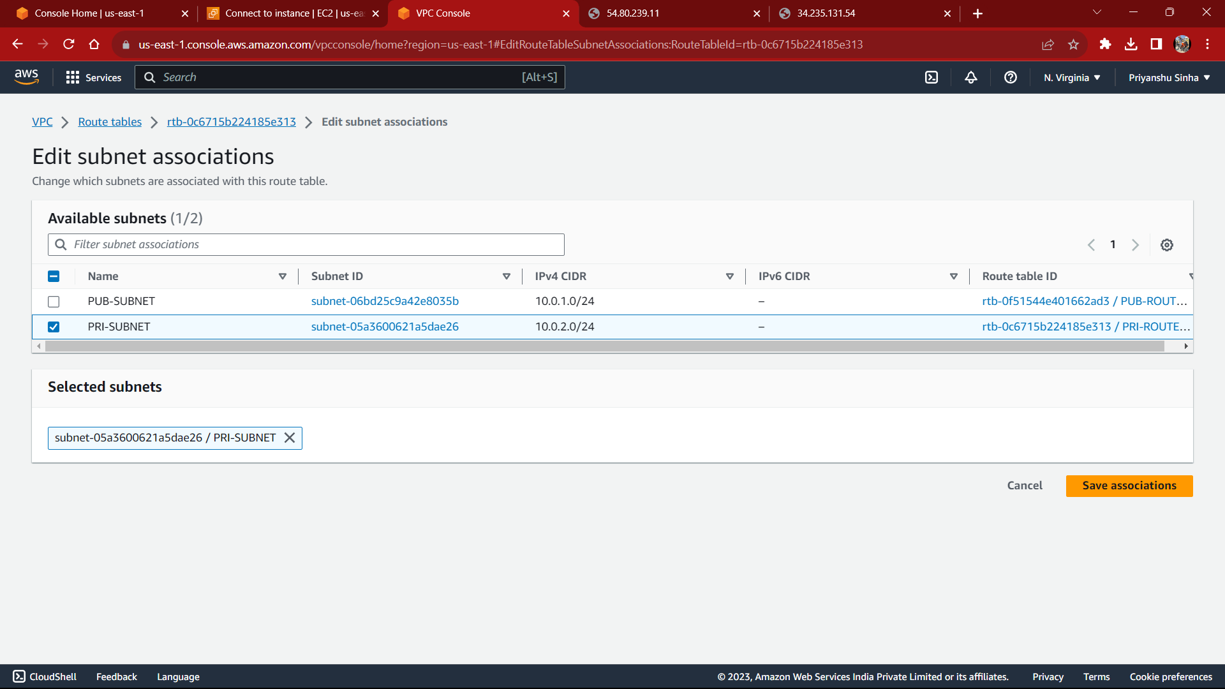

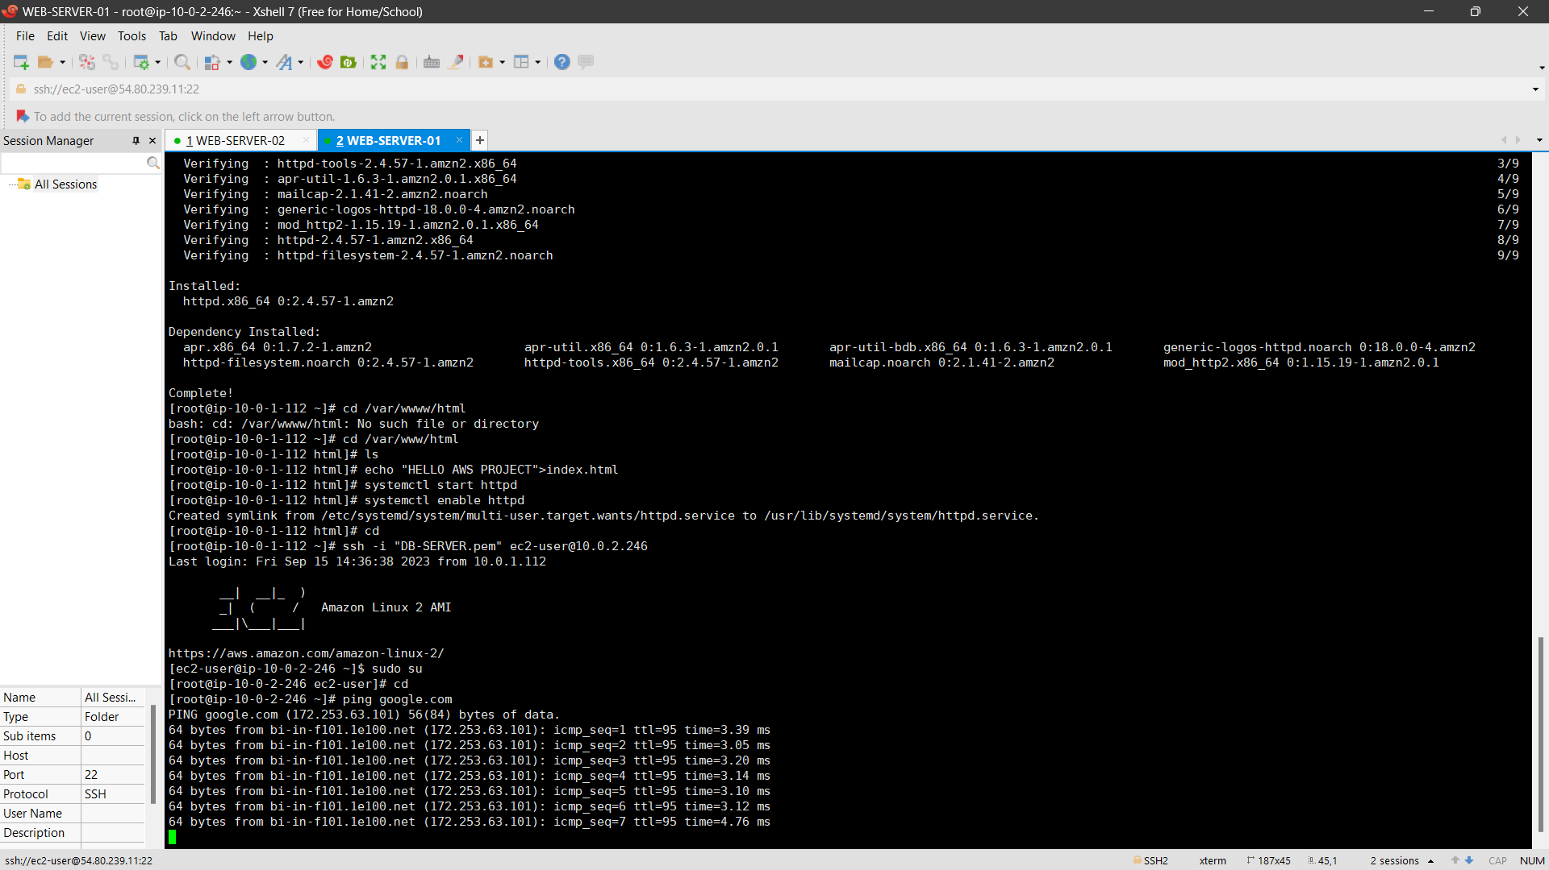

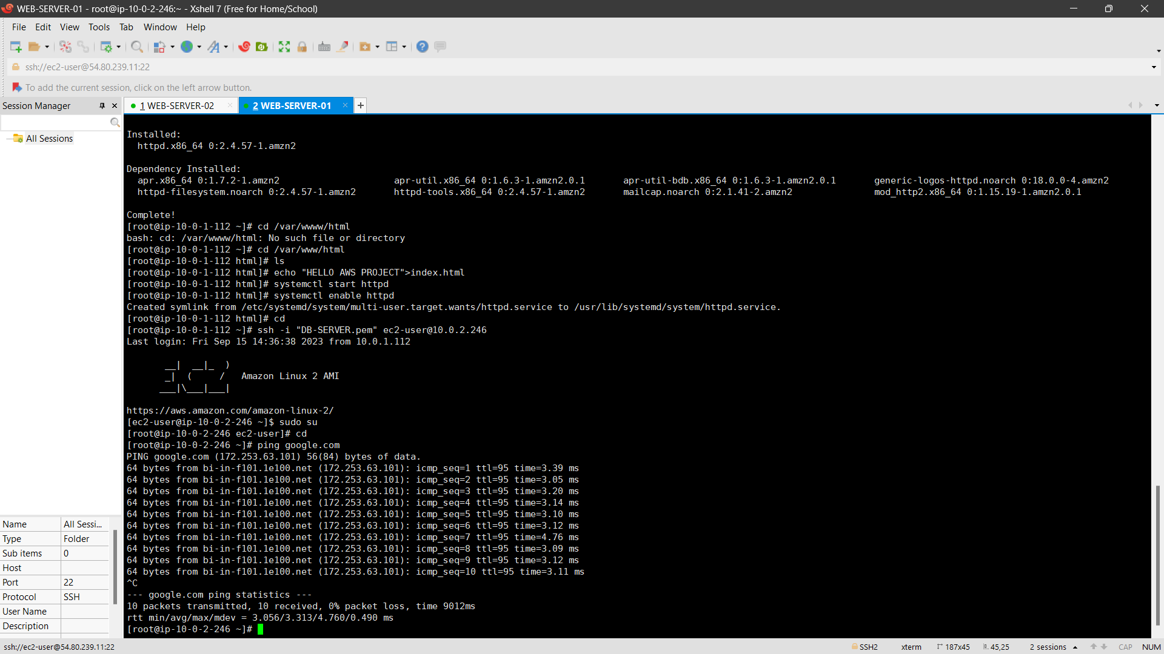

9.CONFIGURE LOAD BALANCER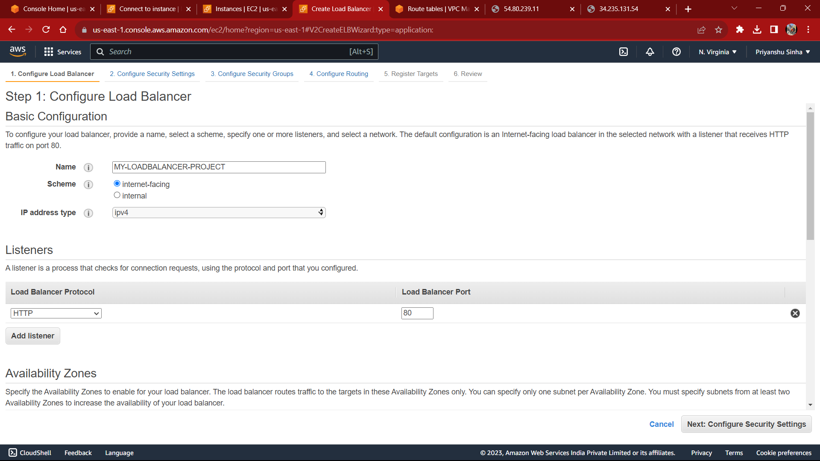

10.CONFIGYRE SECURITY SETTING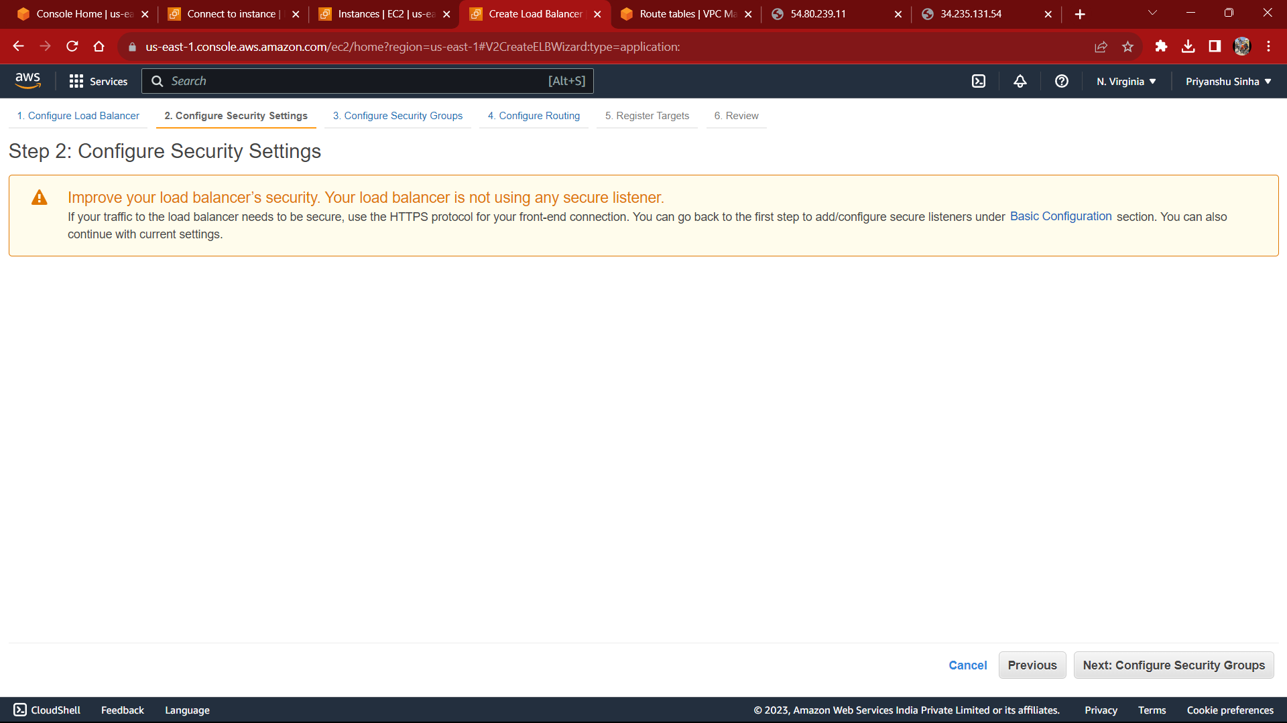

11.CONFIGURE SECURITY GROUP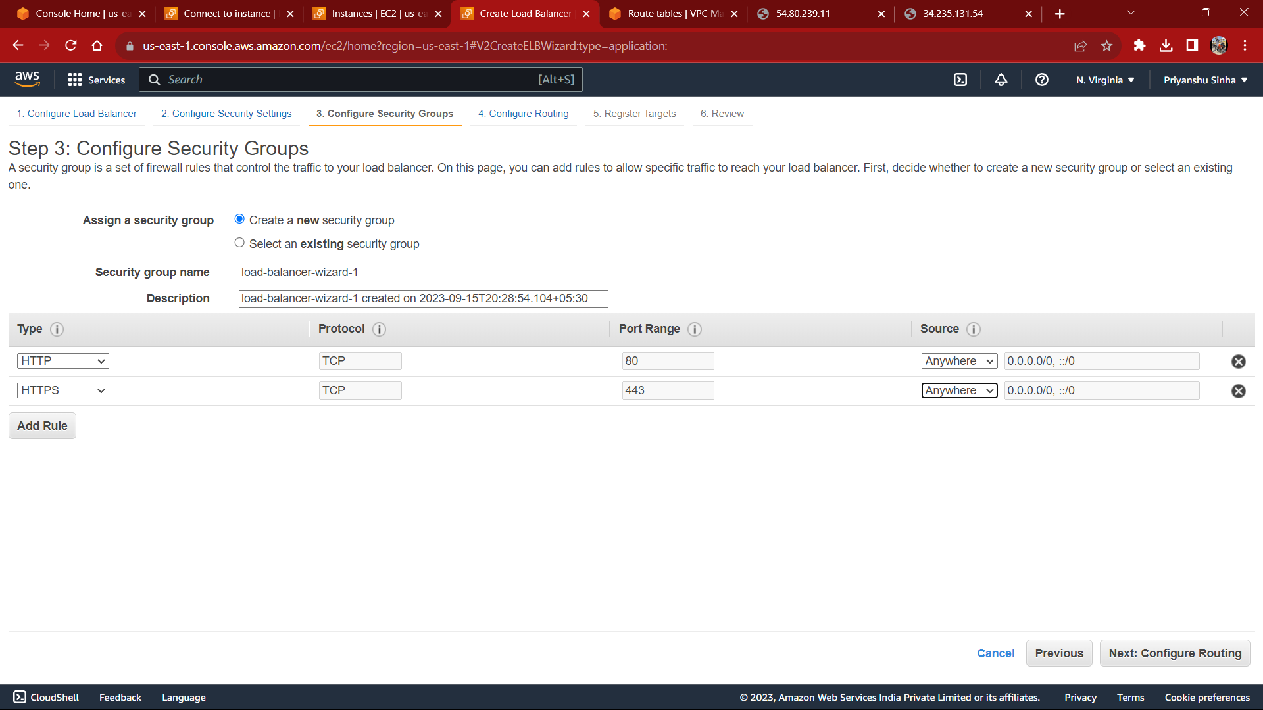

12.CONFIGURE ROUTING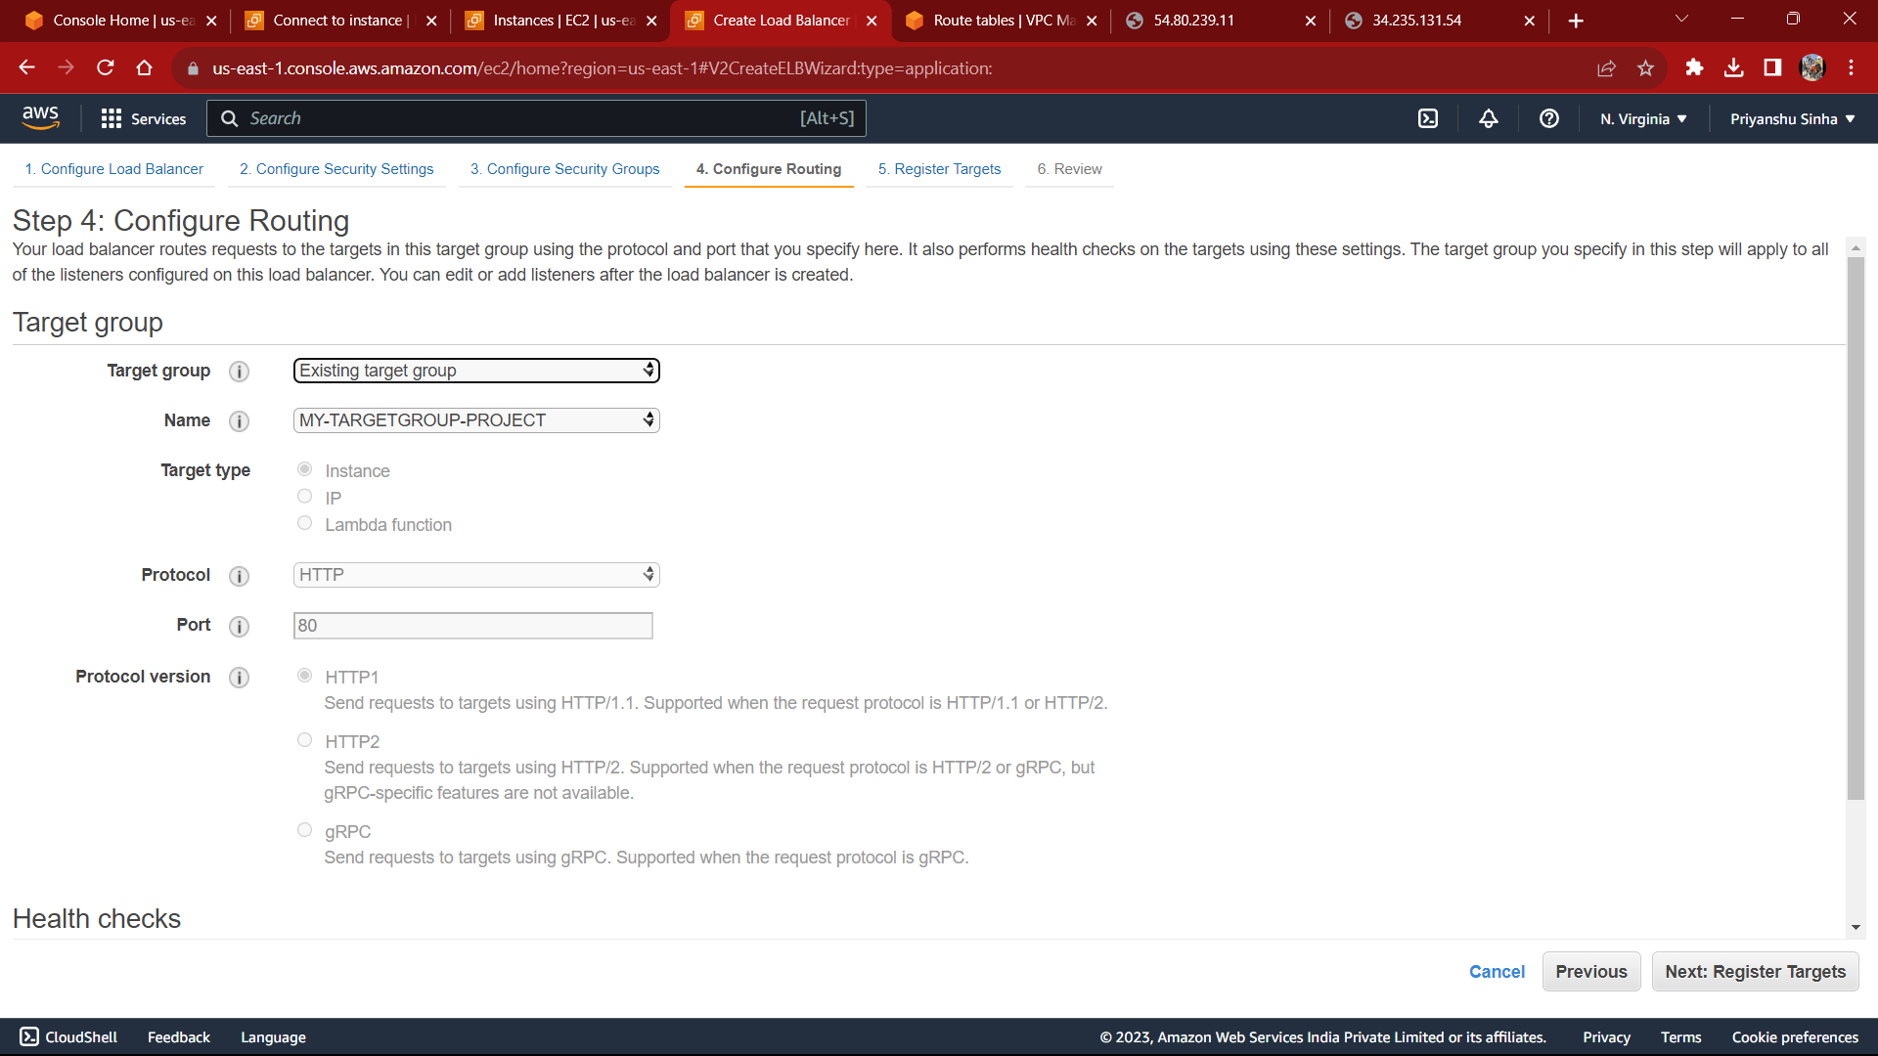

13.REGISTER TARGET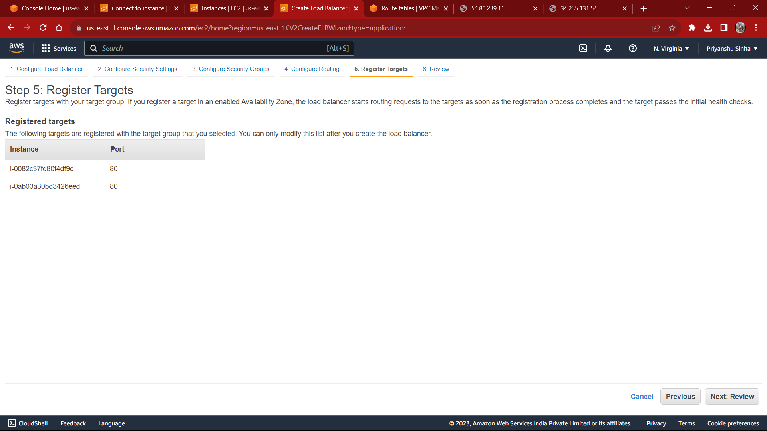

14.LAST CHECKING AND VERIFICATION OF APPLICATION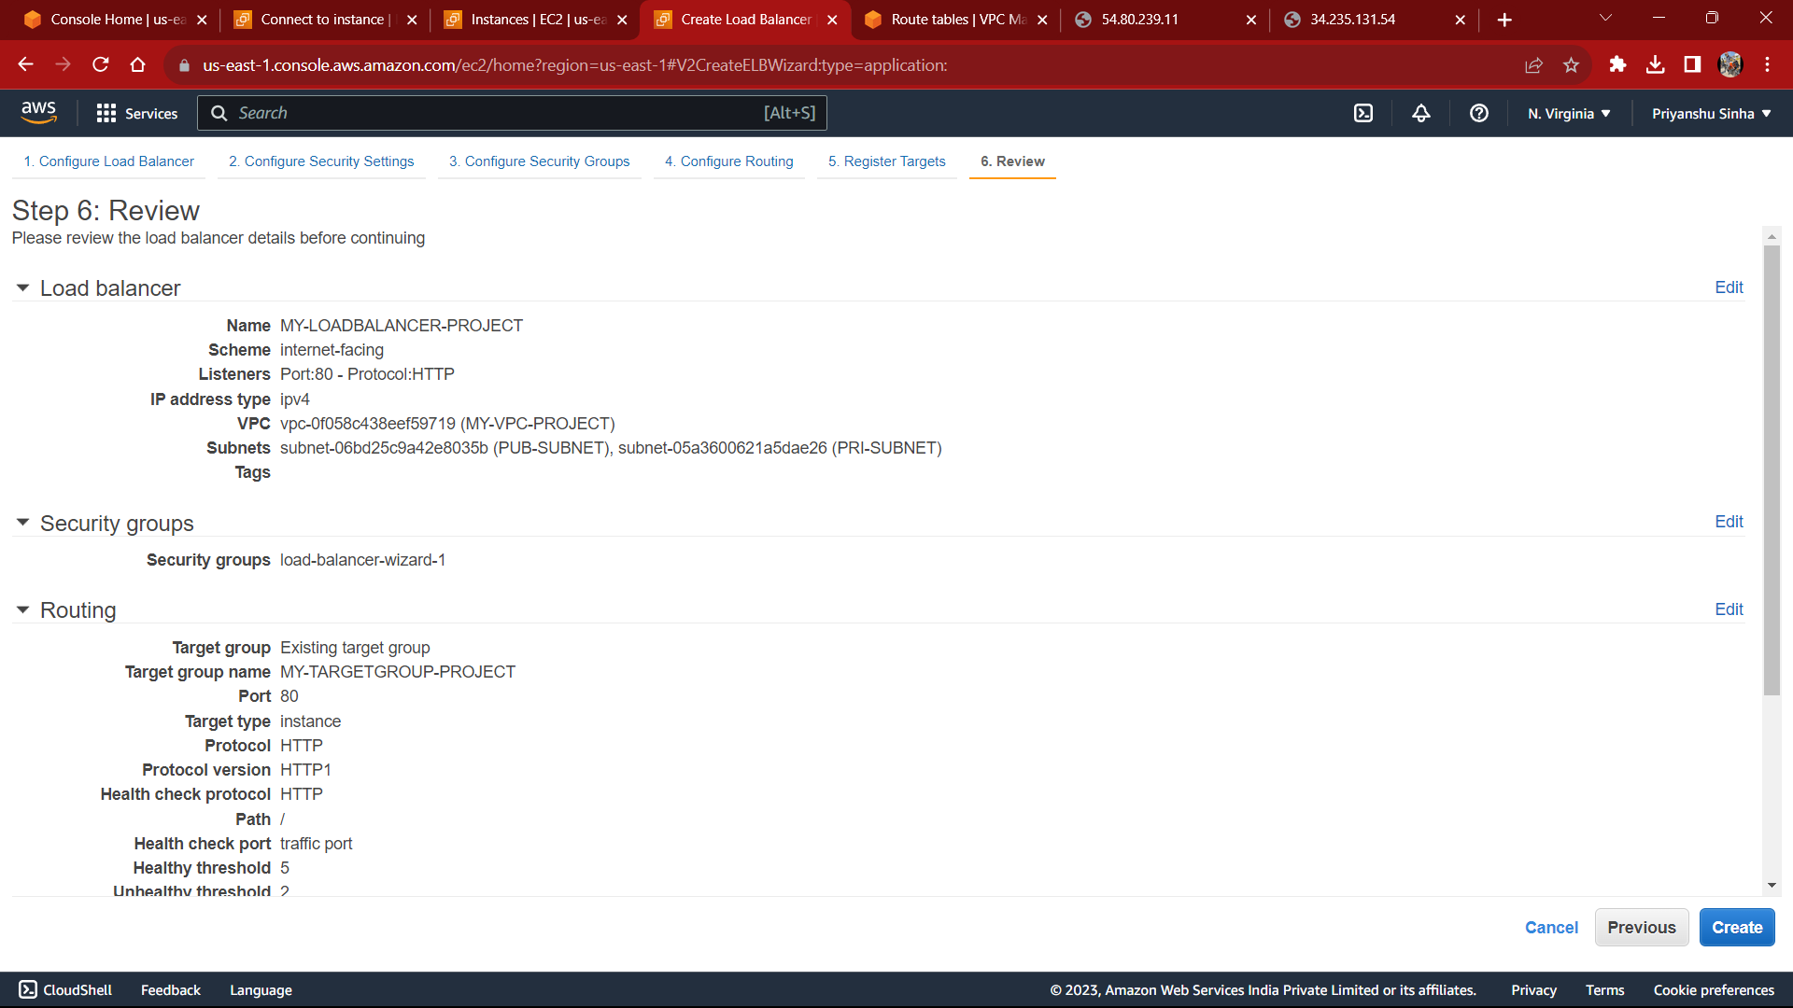

15.CONNECT TO LOAD BALANCER THROUGH DNS 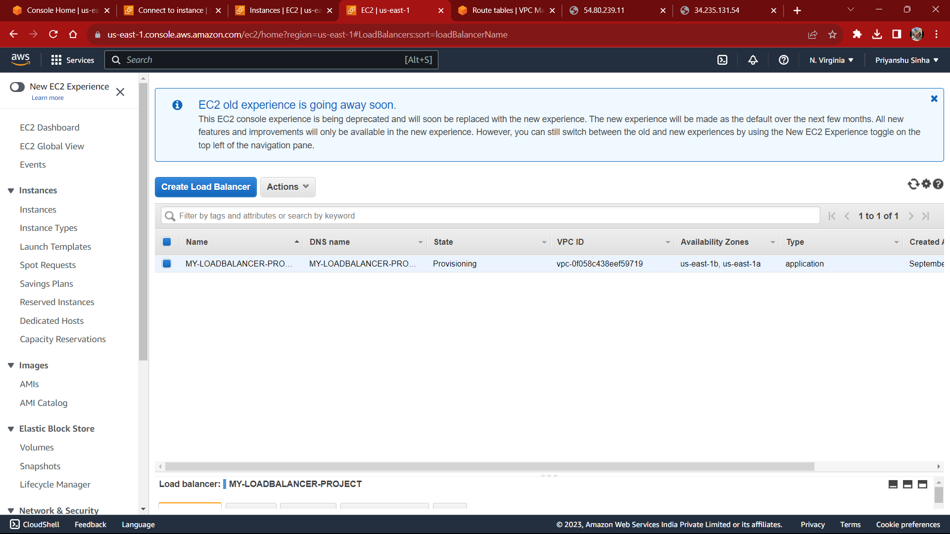



16.AUTO SCALING

CREATE IMAGE(AMI) OF WEB SERVER 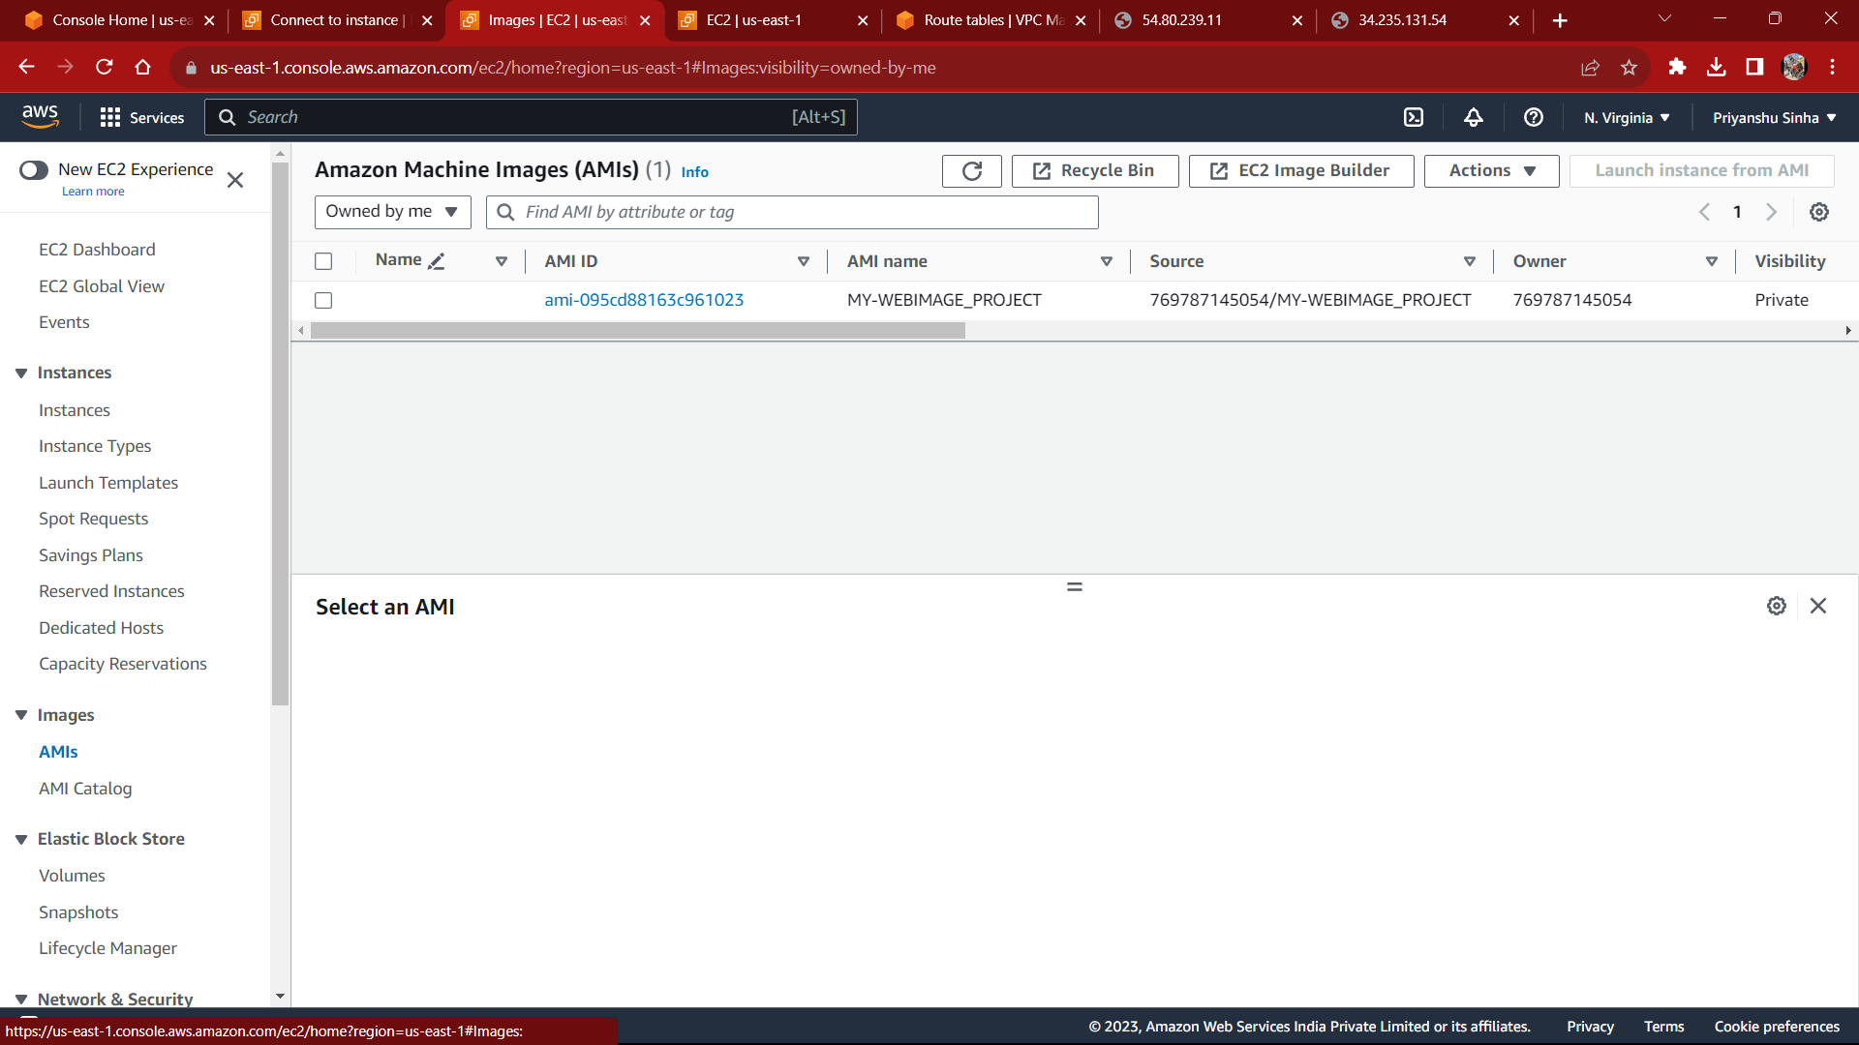

LAUNCH TEMPLATE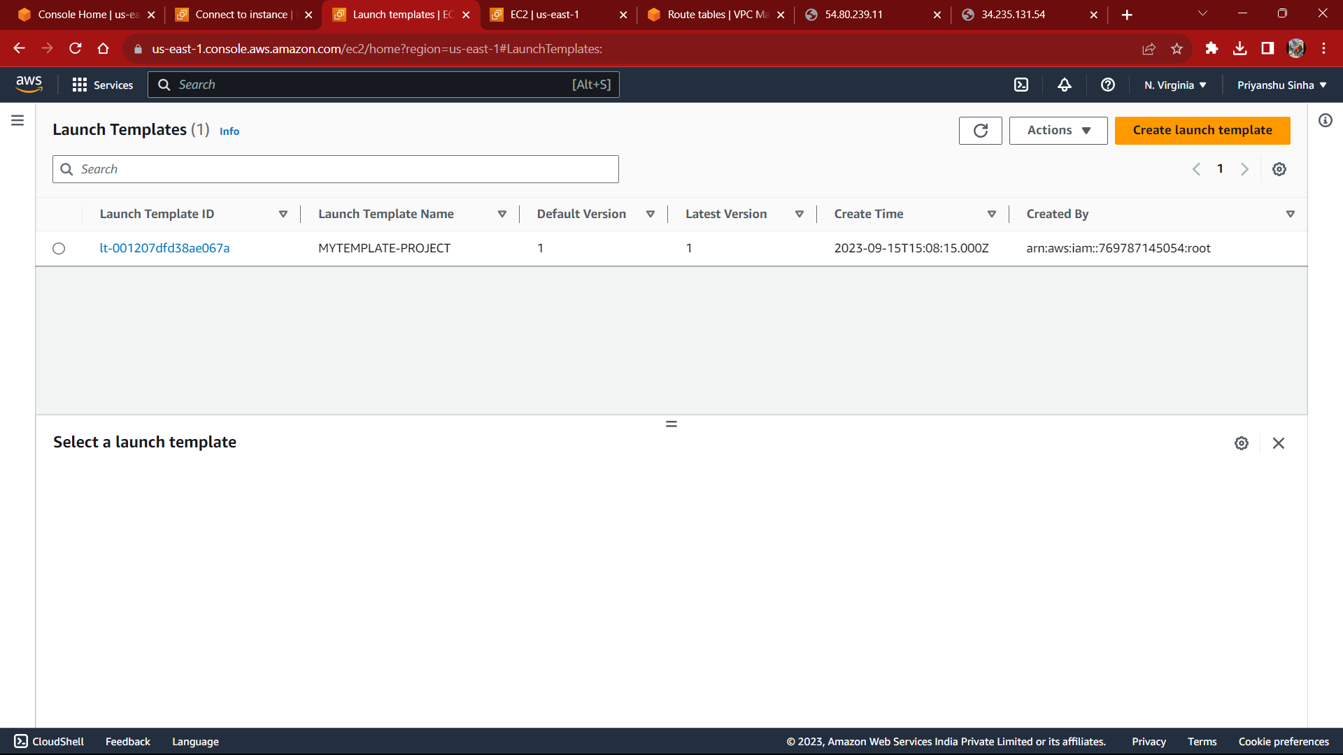

AUTO SCALING GROUP 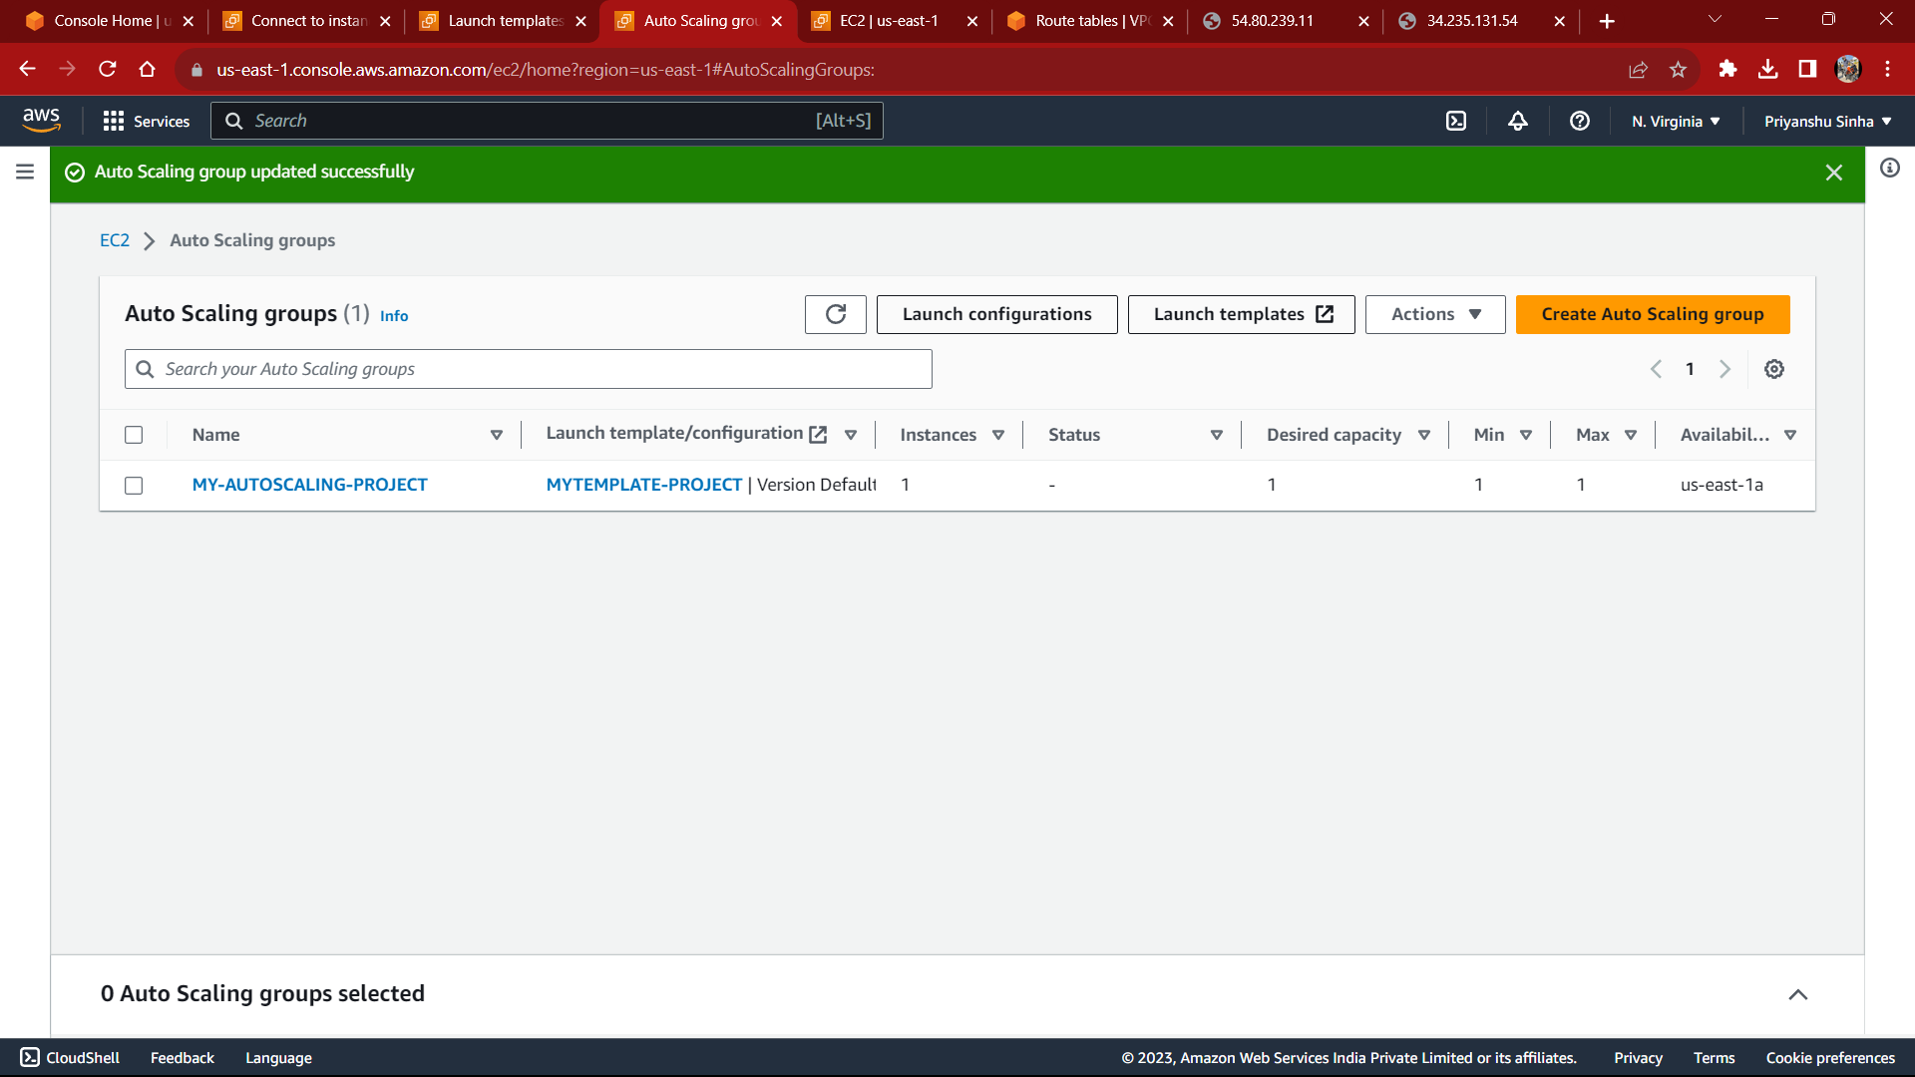

AFTER LAUNCHING AUTOSCALING GROUP, A NEW INSTANCE GETS CREATED 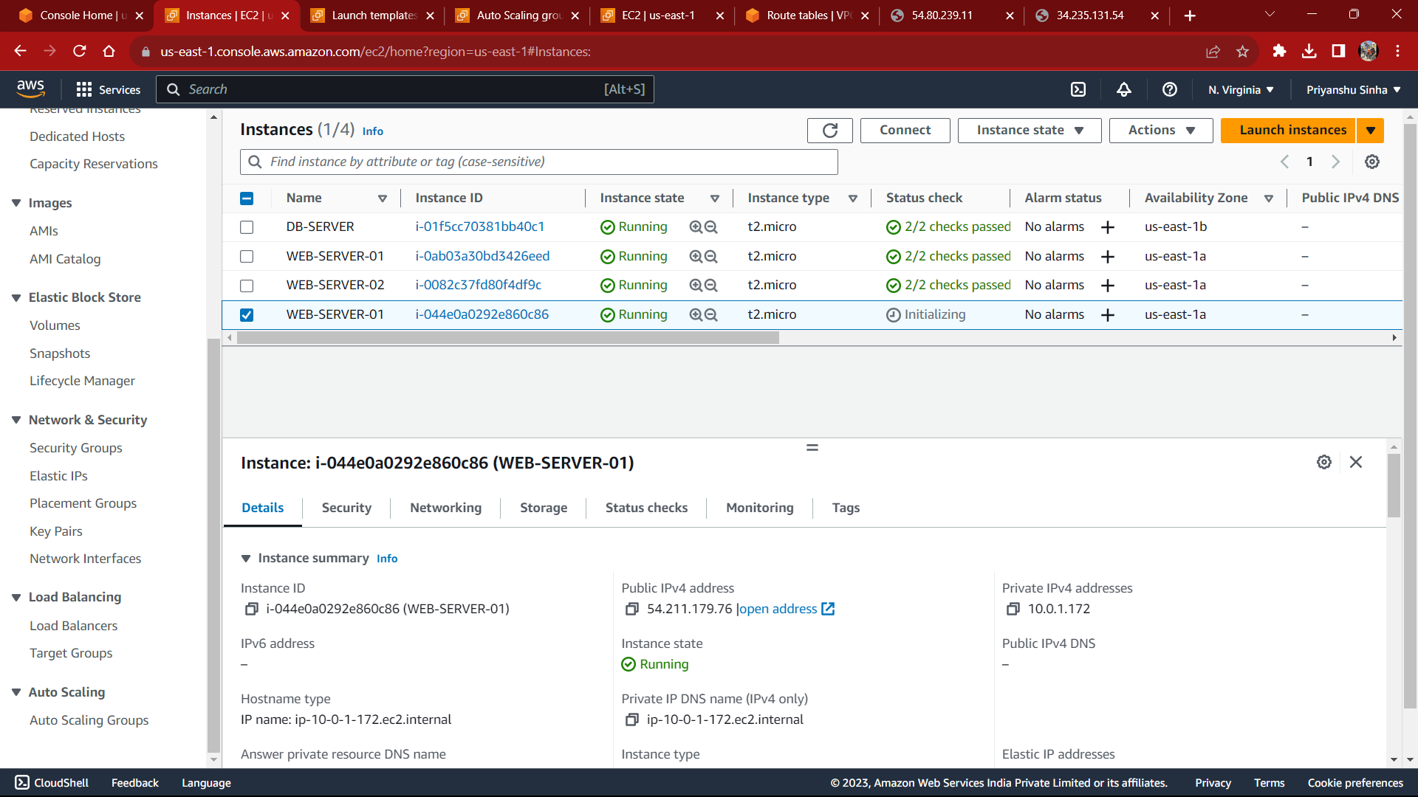

17.PURCHASE DOMAIN FROM HOSTINGER THEN WE SECURE OUR DOMAIN BY SSL CERTIFICATE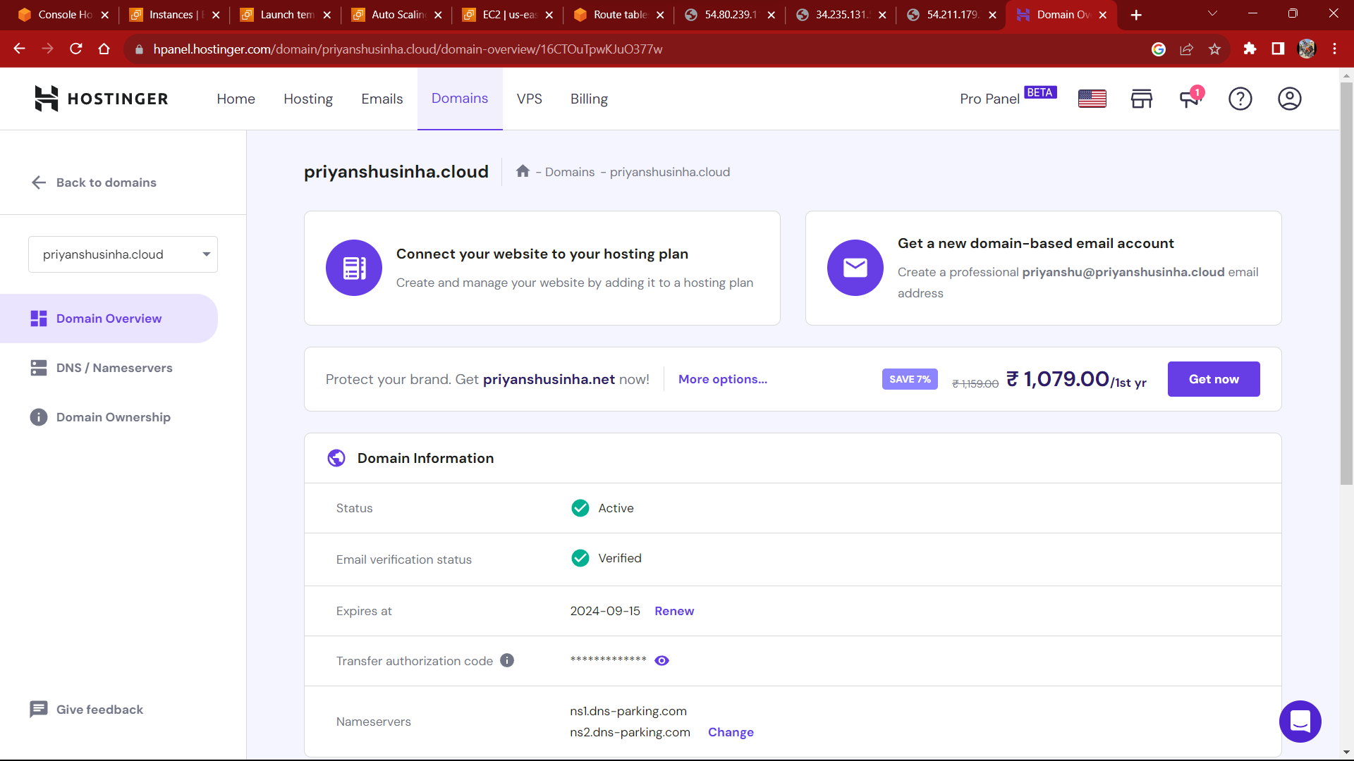

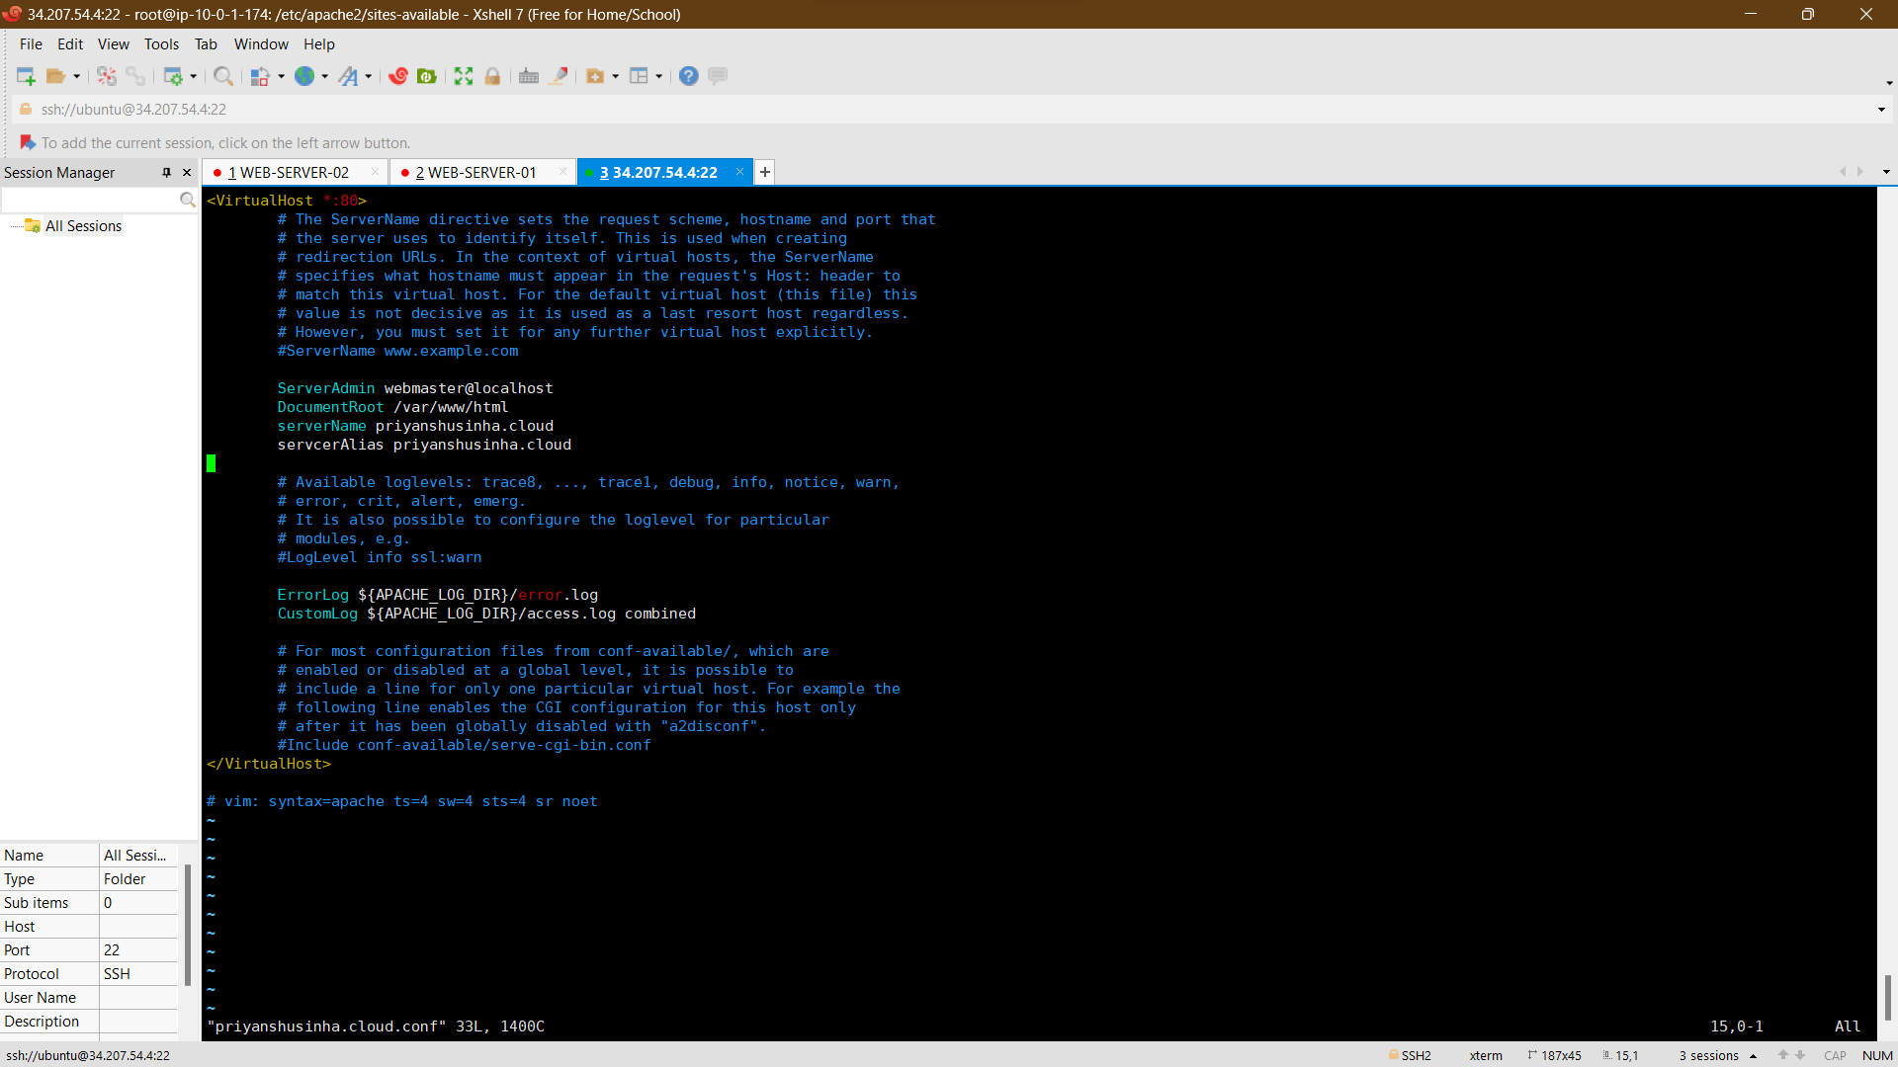

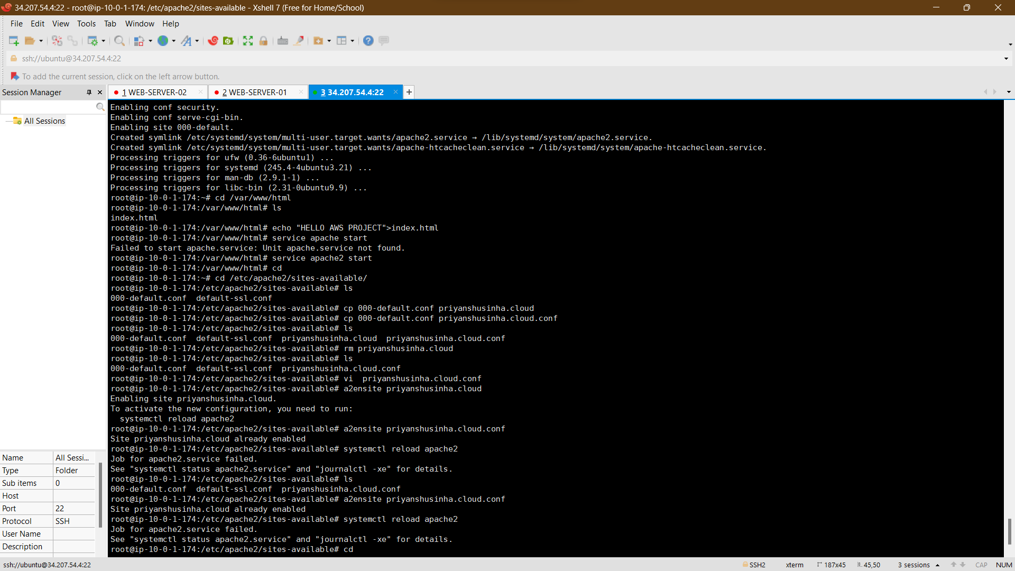

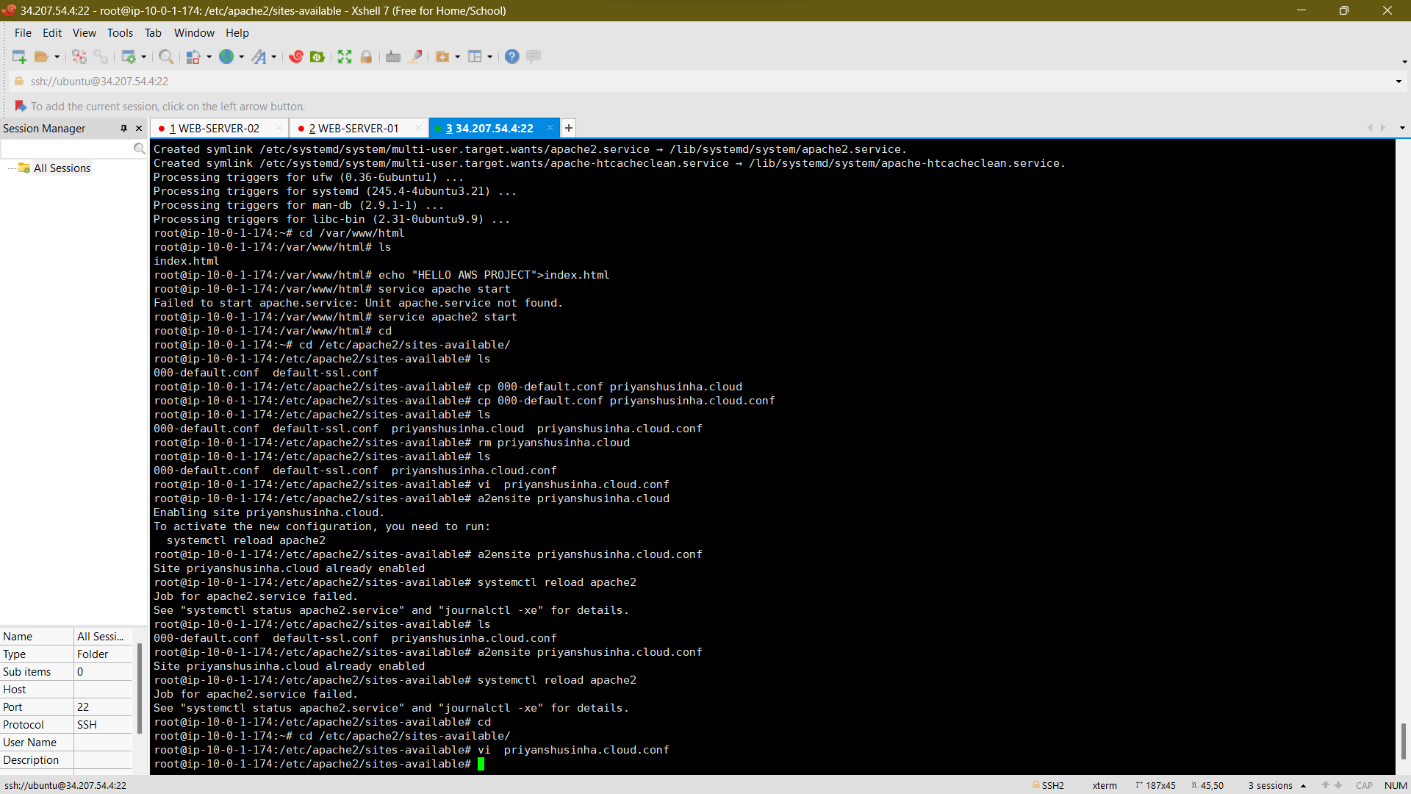

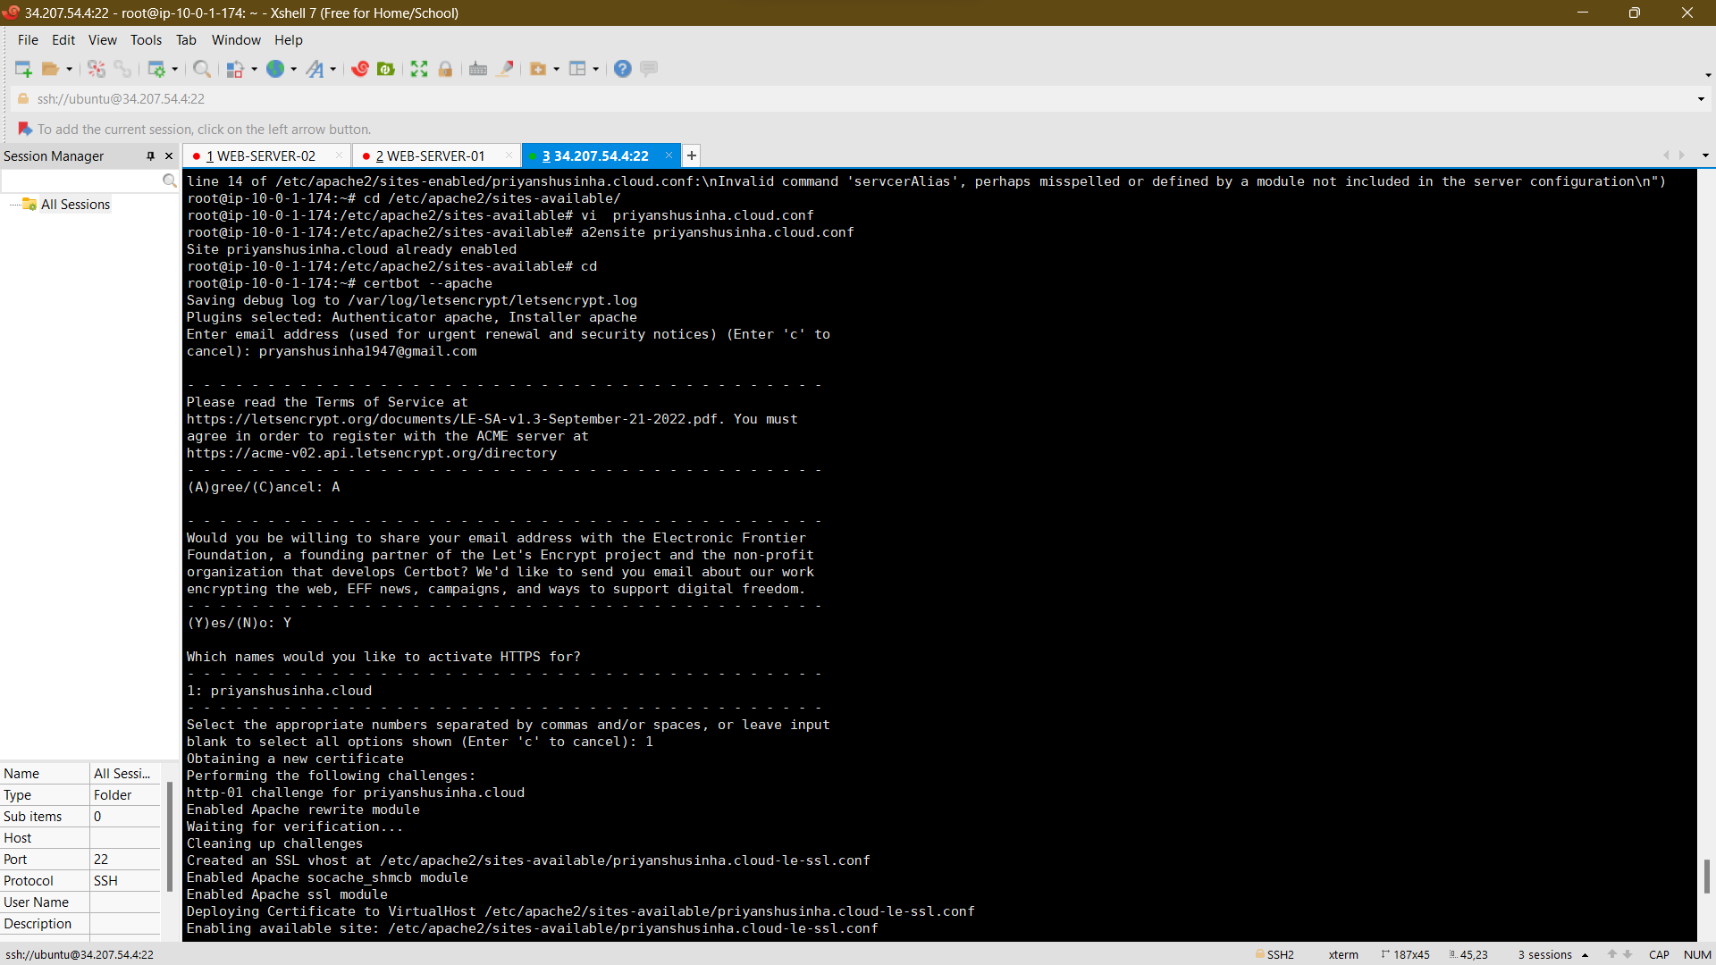

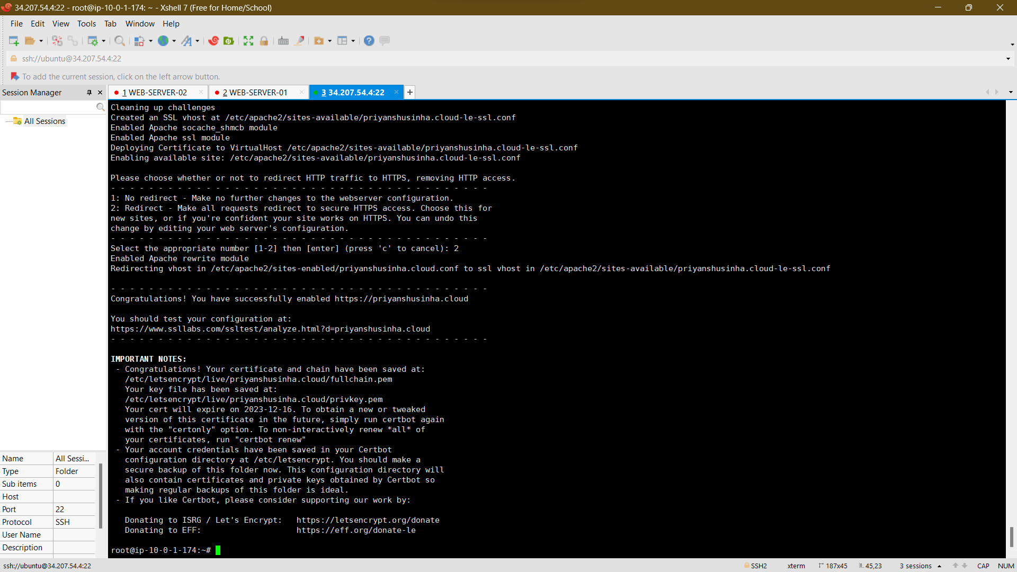

18.OUR CERTIFICATE CREATE FOR VIEWER: ***priyanshusinha.cloud***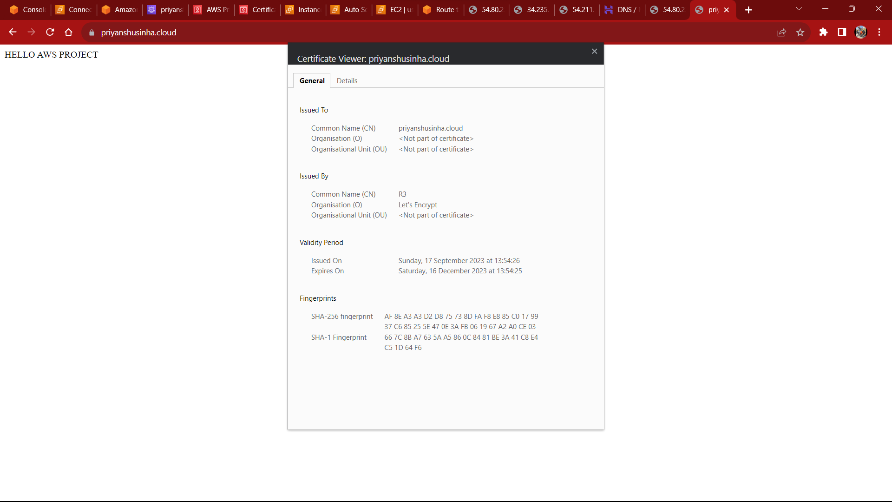

19.CREATE DATA BASE(RDS)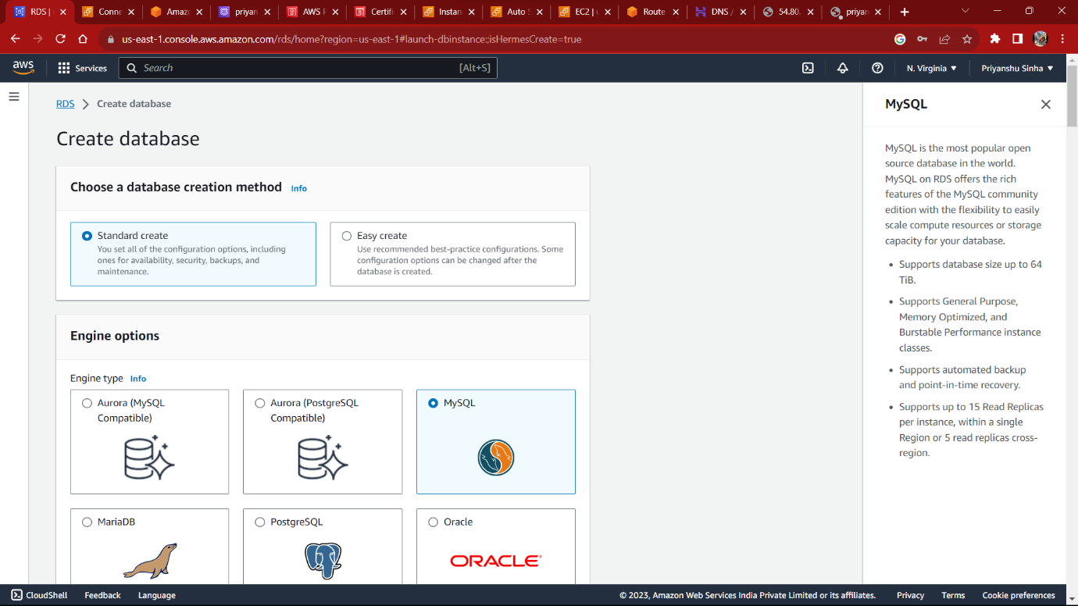

20.OPEN VPN SETUP

CREATING AN OPEN VPN EC2 INSTANCE

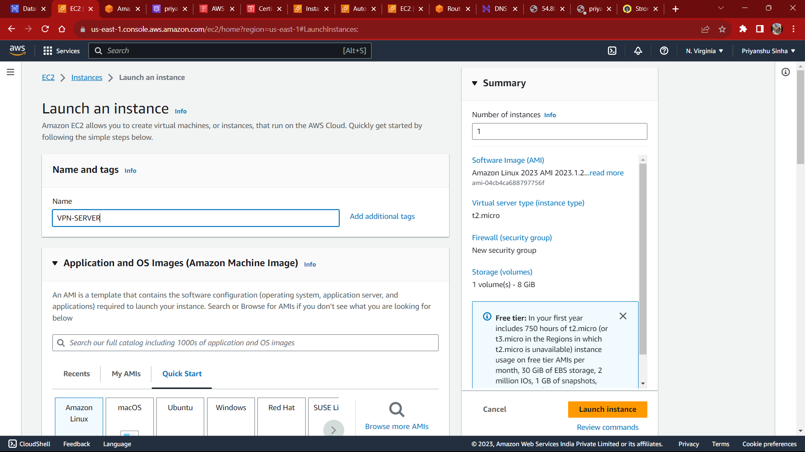

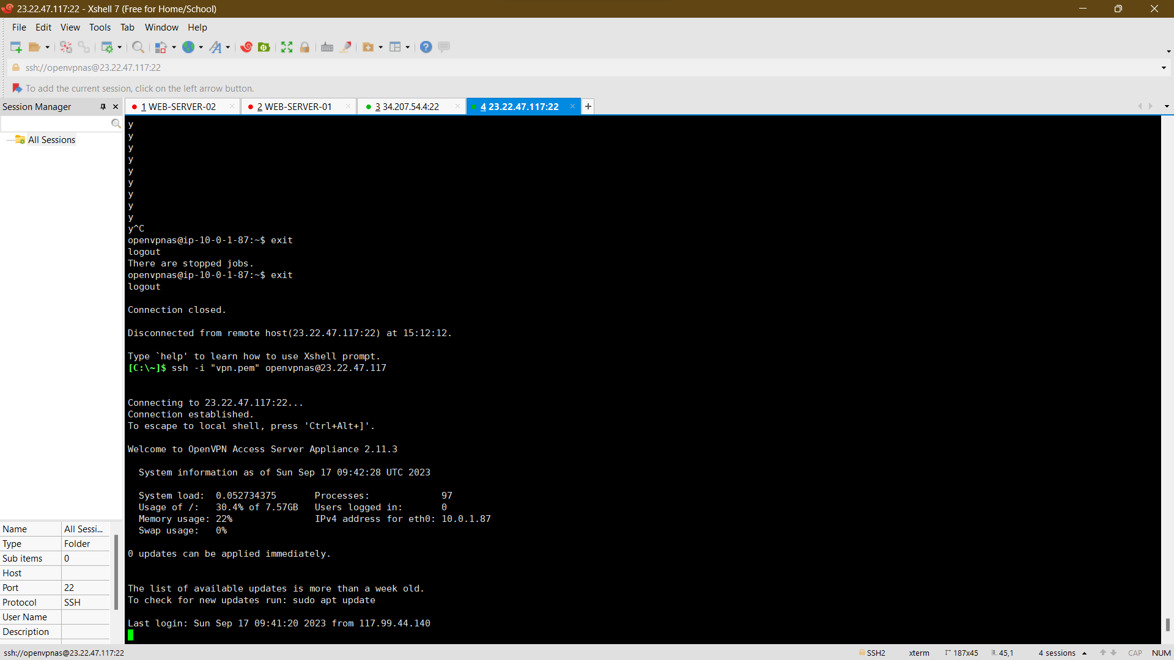

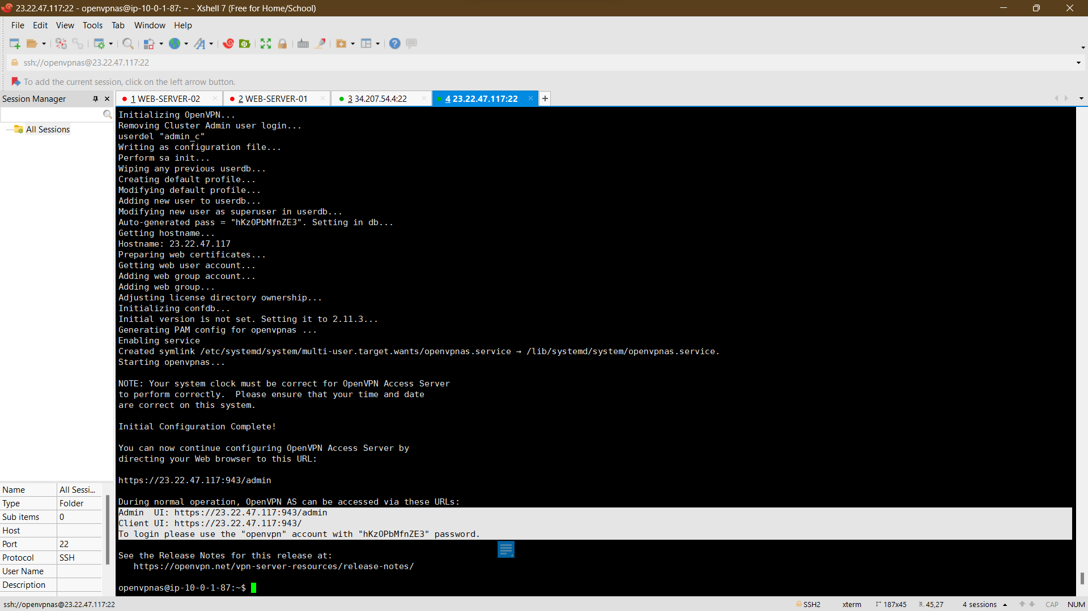

21.VPN ID



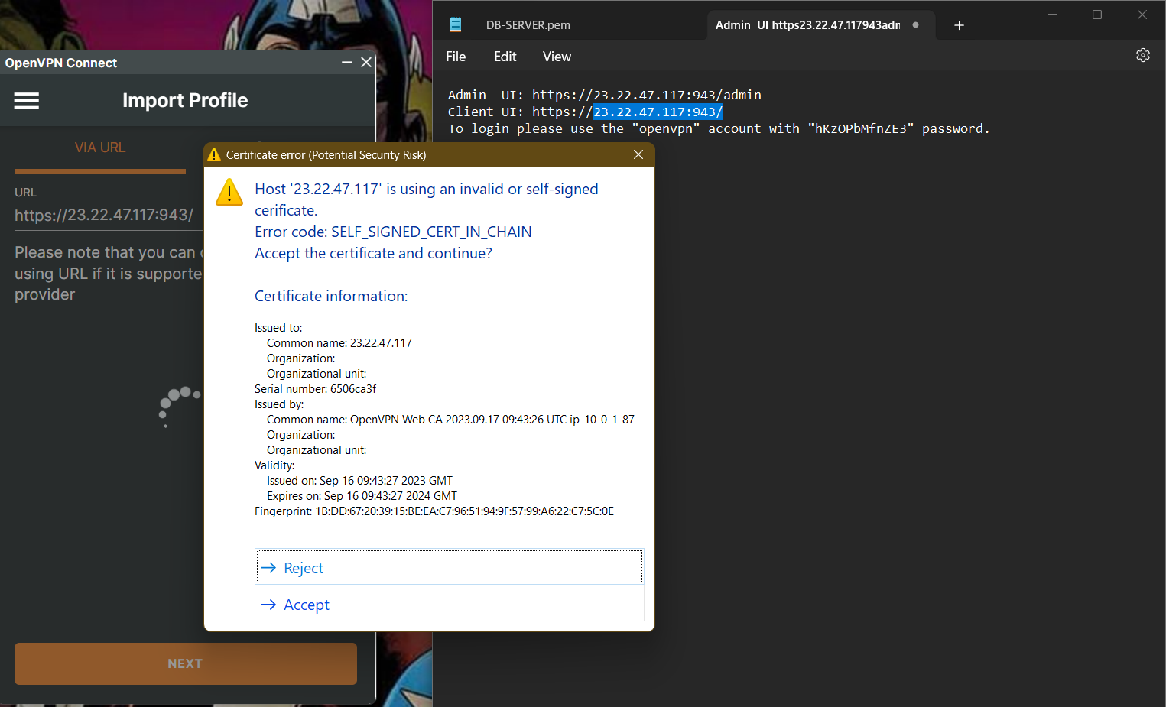

22.OPEN VPN CONNECTED

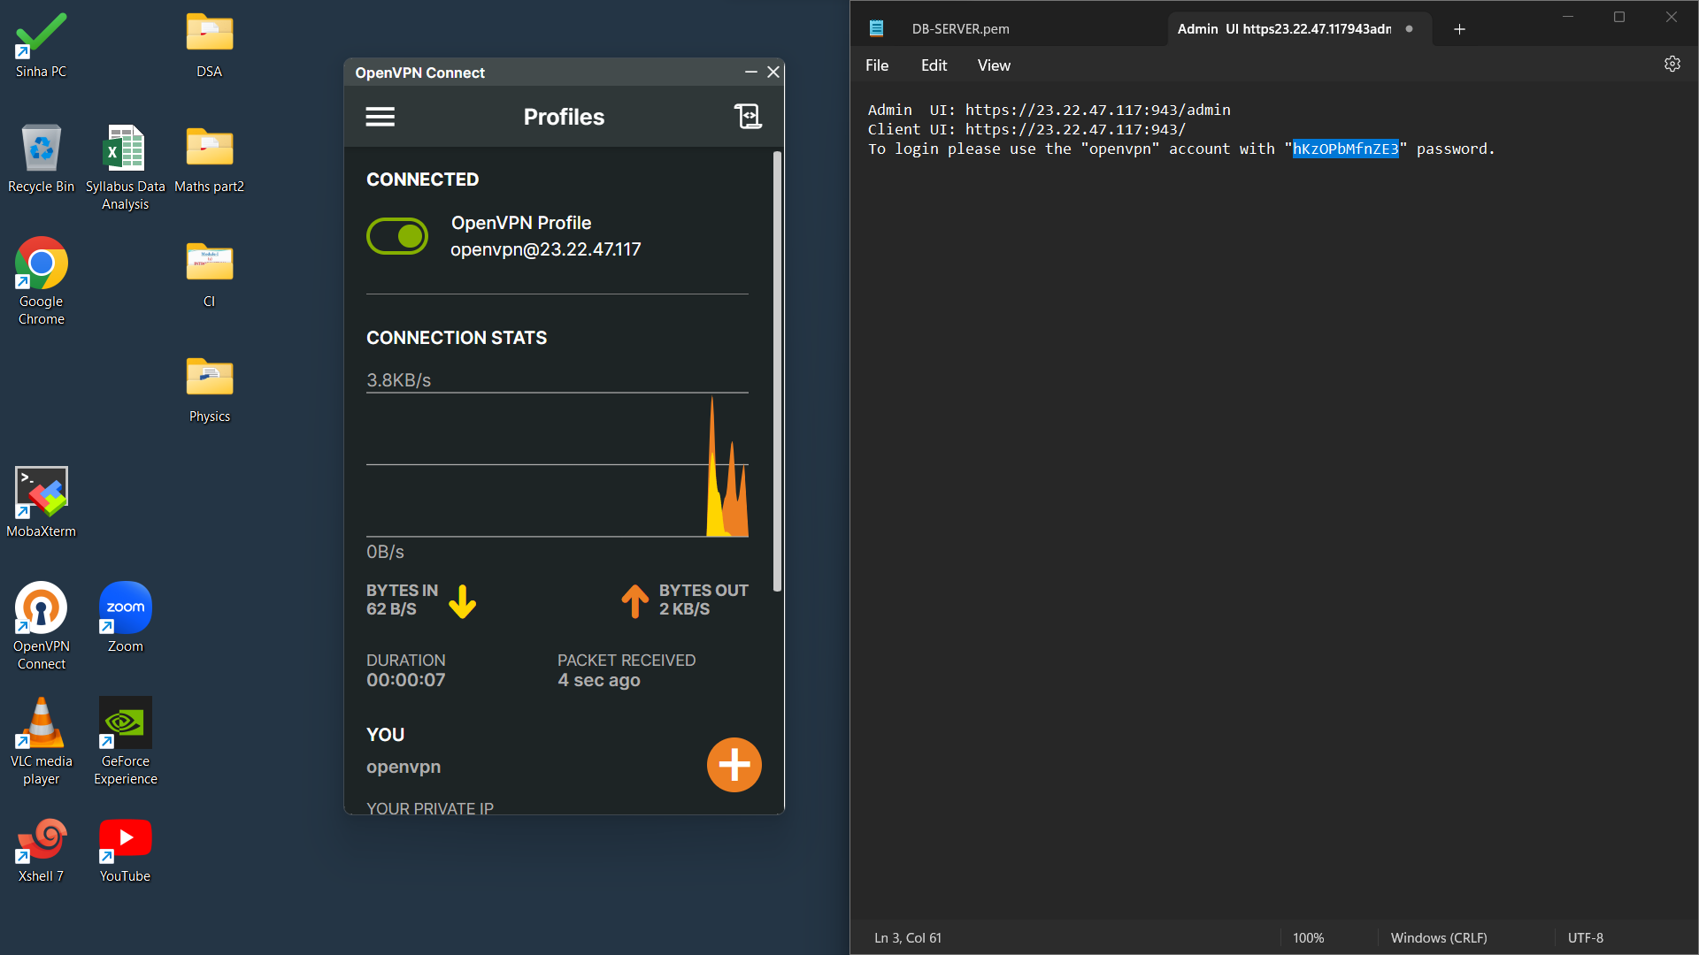

22. NOW WE CAN CONNECT TO OUR DATABASE SERVER THROUGH MY SSH

CONNECT IT BY MY SQL

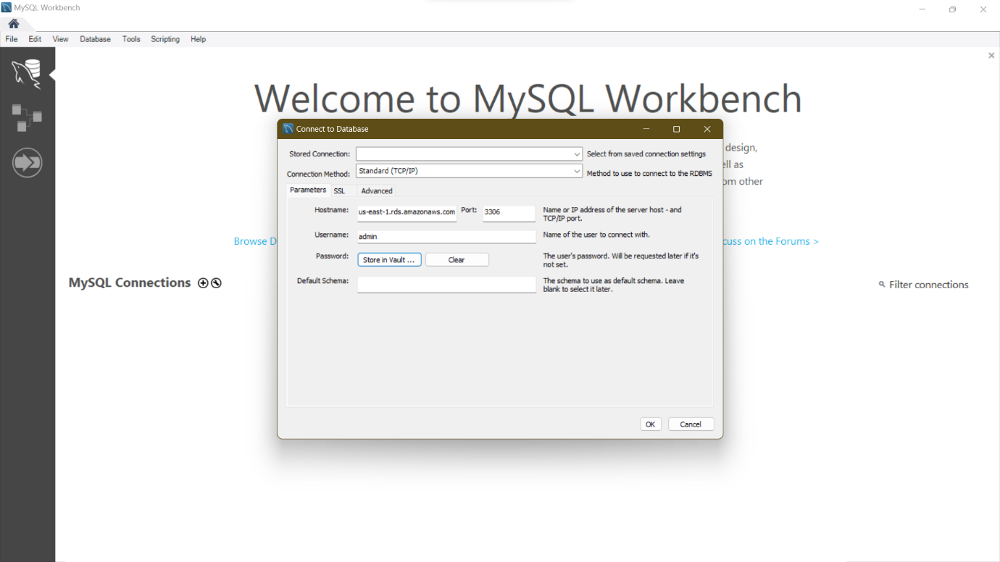

NOW WE CONNECTED SUCCESSFULLY TO MY DB SERVER THROUGH RDS DATA BASE IN MY SQL

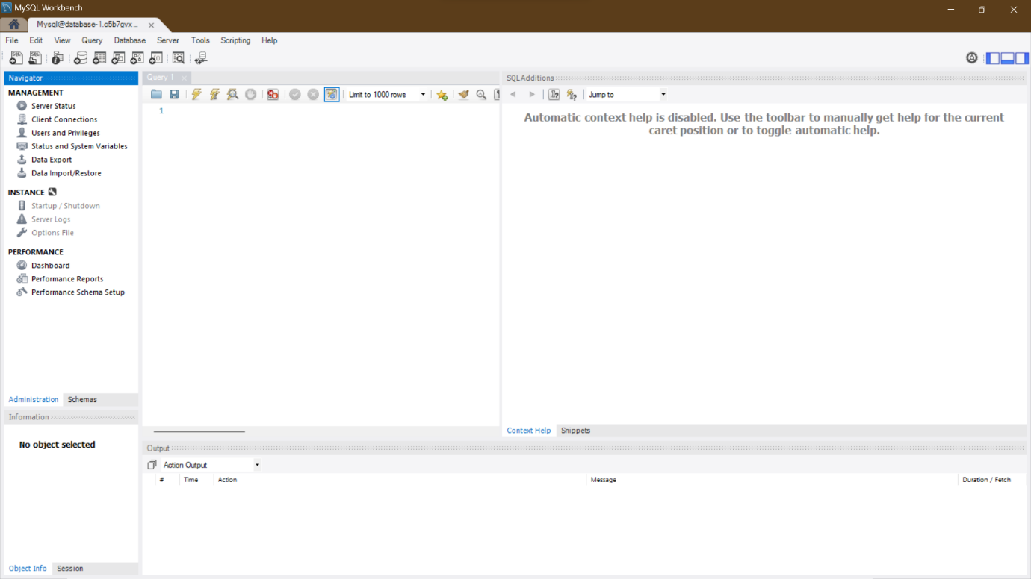

**THANK YOU…**

**NAME-PRIYANSHU SINHA**

**SIC-22BEEC35**

**BRANCH-EEE**